Lab 1 – Determination of the relationship between the surface area of a piece of paper and the diameter of a ball made with it
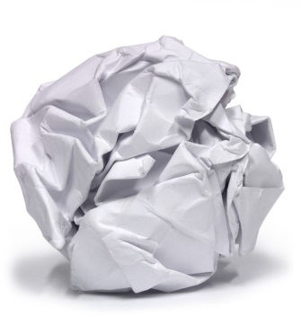
Objective
To learn how to collect data, calculate averages and errors in direct and indirect measurements express them correctly, make graphs including the error as error bars, interpret results, assess and evaluate the method.

The results, conclusion and evaluation will be completed as a group on your blog page.

Procedure
- Take two sheets of paper from your notebook and measure the length and width of the paper with a 50 cm (±0.1 cm) ruler.
- Make a ball with the paper and measure its diameter with the ruler a minimum of 5 times. (Record all data in a suitable table)
- Divide the second sheet in half and repeat the process (assuming the surface area is half the first one)
- Continue this process until a minimum of 5 different sized balls have been made and measured.
- Calculate the average diameter for each paper and display your results in the form of a scatter graph with a line of best fit.

Conclusion
- Describe any correlation present in your graph.
- Explain what this correlation means about your investigation.
Evaluation
- Go through each step of the procedure in this experiment and consider if there are any possible errors associated with it. (Read the sections on measurements in Unit 1 on the science website and try to use key terms related to error – systematic, parallax and random)
- List a minimum of 3 improvements that could be made to improve the accuracy of this investigation.

Error sources | Improvements

