NATURAL SCIENCES DEPARTAMENT | 1st term  Physics and Chemistry 10th grade
Name and surname
Date ____________________ Mark. A_____. B_____. B_____. D_____. E_____. F_____.

Criterion B: Inquiring and designing
Level of Acheivement |  | Level Descriptor
0 | The student does not reach the standard described in any of the levels below.
1-2 | The student is able to:  i. state a problem or question to be tested by a scientific investigation  ii. outline a testable hypothesis  iii. outline the variables  iv. design a method, with limited success | The question or problem of investigation is adequate, but it is expressed using minimal scientific vocabulary not based on investigation.  The hypothesis is broadly defined according to theory.  Variables have been identified and described, but the distinction between them is incorrect or missing.  The method does not allow the effective development of the investigation.  No reference list is included.
3-4 | The student is able to:  i. outline a problem or question to be tested by a scientific investigation  ii. formulate a testable hypothesis using scientific reasoning  iii. outline how to manipulate the variables, and outline how relevant data will be collected  iv. design a safe method in which he or she selects materials and equipment | The question or problem of the investigation is described in broad terms, and is based on some research.  The hypothesis is expressed, but not scientifically justified.  Variables are correctly identified as independent and dependent, but the controls are incomplete.  The manipulation of all the variables is explained in broad terms.  The method allows for the collection of relevant data.  The method is safe.  A complete list of materials, with their proper names, is included.  A reference list is included
5-6 | The student is able to:  i. describe a problem or question to be tested by a scientific investigation  ii. formulate and explain a testable hypothesis using scientific reasoning  iii. describe how to manipulate the variables, and describe how sufficient, relevant data will be collected  iv. design a complete and safe method in which he or she selects appropriate materials and equipment | The question or scientific problem of the investigation described using scientific vocabulary, based on some research.  The hypothesis is clearly and systematically expressed, scientifically justified using theoretical background.  Variables are correctly identified as independent, dependent and controlled  The manipulation and measuring and controlling of all the variables is explained  The method allows for the collection of sufficient and relevant data.  The method is completely clear, safe and logically structured.  A complete list of materials, with their proper names, is included.  A reference list is included in APA format.
7-8 | The student is able to:  i. explain a problem or question to be tested by a scientific investigation  ii. formulate and explain a testable hypothesis using correct scientific reasoning  iii. explain how to manipulate the variables, and explain how sufficient, relevant data will be collected  iv. design a logical, complete and safe method in which he or she selects appropriate materials and equipment. | The question or scientific problem of the investigation is well described using scientific vocabulary, based on previous research.  The hypothesis is clearly and systematically expressed, scientifically justified using the correct theoretical background.  Variables are correctly identified as independent, dependent and controlled.  The manipulation and measuring and controlling of all the variables is well explained.  The method allows for the collection of sufficient and relevant data.  The method is completely clear, safe and logically structured.  A complete list of materials, with their proper names, is included.  A reference list is included in APA format.

Title: Design an investigation on a factor that could affect to the evaporation rate of a substance

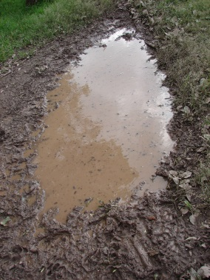
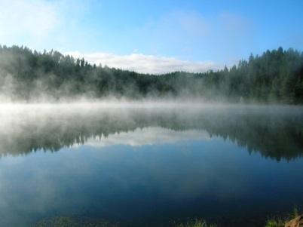
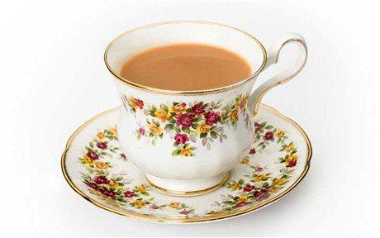

Research question: The question that you will attempt to answer with your investigation.

Introduction: Relevant and useful information on the topic of the research. The level of detail should be enough to fully explain the hypothesis. Include full in-text referencing.

Hypothesis: Answer to the research question and scientific justification, based on the previous information.

Variables: Independent, dependent and controlled (at least 3 must be considered).

Materials: List containing specifically named equipment and chemicals required (with approximate quantities).

Method: Numbered instructions.

References: In APA format all the resources from which the information has been obtained according to your in-text references.

Formative assessment: Tuesday 3rd November

