Session 13: | Rate of Enzyme reactions

Assessed criteria
Criterion C: Processing and Evaluating

Criterion E: AIE

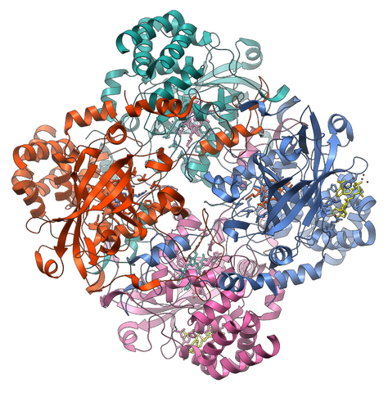

Research Question
“Is there an optimum temperature for catalyzing reactions?”

Background Information
Many organisms can decompose hydrogen peroxide (H₂O₂) enzymatically. Enzymes are globular proteins, responsible for most of the chemical activities of living organisms. Most organisms have a preferred temperature range in which they survive, and their enzymes most likely function best within that temperature range. If the environment of the enzyme is too hot, the enzyme may irreversibly denature, or unravel, until it no longer has the shape necessary to function correctly.
H₂O₂ is toxic to most living organisms. Many organisms are capable of enzymatically destroying the H₂O₂ before it can do too much damage. H₂O₂ can be converted to oxygen and water, as follows:
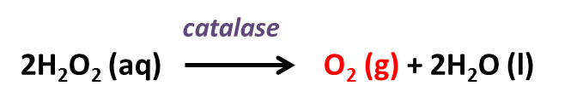
Objective
To study the effect of temperature on the activity of catalase enzymes.

Hypothesis (Complete this section)
…………………………………………………………………………………………………………………………………………………………………………………………………………………………………………………………………………………………………
Materials
Commercial H₂O₂ | 5 test tubes | Water bath
Soap (fairy) | Test tube rack | Ice
Potato | 5 mL pipette | Thermometer
Potato chopper | Dropper | Stopwatch
Knife | Beaker | Ruler
 |  | Goggles

Method

- Fill each test tube with 3 mL of H₂O₂ and 3 mL of water using a pipette.
- Using a clean dropper pipette, add 2 drops of soap to each test tube. Make sure the soap doesn’t stick to the sides of the tube and drops straight into the solution.
- Cut 5 cubes of potato of about 1x1x1 cm, using the chopper or do it carefully with a knife.
- Heat/cool tubes to the temperature indicated by your teacher (10, 20, 30, 40 or 50ºC).
- Add the cubes to the 5 test tubes and begin timing with a stopwatch.
- Measure the froth length after 3 minutes of enzyme catalyzed reaction using the ruler.
- Calculate the average and SD of your 5 trials.
- Obtain results of all other scientists in the lab using a shared spreadsheet in Teams. Design a table with all data and draw conclusions from a graph produced with the average class results of each temperature and error bars with the SD.

Results (Complete this section)
- Record all the values on a table.
- Draw a graph which represents temperature against height of foam. Add a trend line and error bars.

Conclusion (Complete this section)
Draw conclusions from your graph and link to scientific reasons (see background information).

Evaluation (Complete this section)
How accurate are your results? What stages of the method might have changed the accuracy of your measurements? Think of at least three weaknesses and suggest an improvement for each.

References (Complete this section with APA references Make sure he in text references are in the report when you have used information of a certain source)

