Session 13: | PLANNING AND PERFORMING AN IVESTIGATION INTO GERMINATION

Assessed criteria
Criterion B: Planning an investigation (Summative)

Criterion C: Data Processing (Summative)

Research Question
“How does a chosen factor affect germination?”

Introduction

Flowering plants reproduce with seeds, that can lay dormant for long periods of time and then start to grow (germinate) when there is enough water and the temperature is warm enough (natgeokids.com, 2018).

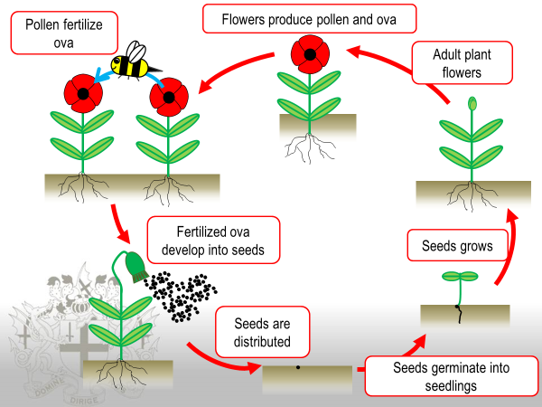

We can germinate seeds in soil, or on tissue paper/cotton wool that holds the water the seeds need. It has been proposed that pollution and acid rain can damage the soil so that the plant life cycle is under threat (gsu.edu, 2018). We could model the effect of acid rain, fertilisers, oil and so on in the lab by geminating seeds in a petri dish.

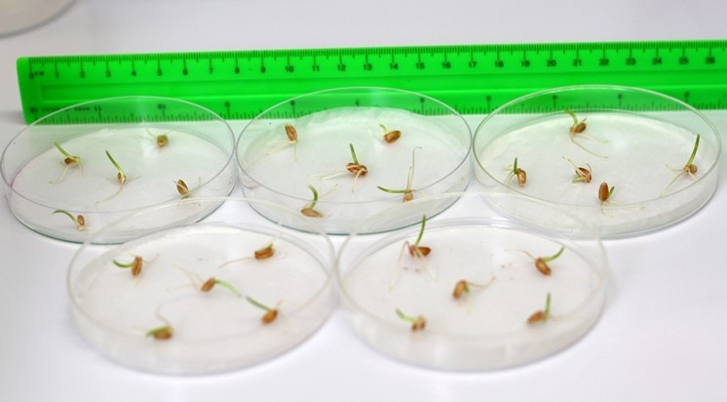

You will choose 1 factor to investigate.

Planning your experiment:

Decide which of the variables you are going to investigate and how you can ensure that your experiment is a "fair test".

You must then decide the range over which you are going to make measurements and how many measurements you should make. e.g. if you were varying the temperature, should you make measurements every degree, every 5 degrees, every 10 degrees etc?

Make sure you define germination in your background information.

Making a hypothesis

Try to make a prediction of what your results will show. e.g. if you were planning to change the temperature, would you expect the number of germinated seeds to increase or decrease with an increase in temperature?

You should also try to give a scientific reason for your prediction.

Processing your data

Usually, the best way to display your data is in the form of a graph. (remember that all graphs should have titles and the axes should have labels and units). The points you should cover are:

Do your results support your prediction?

Are there any trends or patterns in your results?

Have any other researchers performed a similar experiment? What did they find?

You do not need to perform the experiment yet, but you need to plan your experiment. The formative proposal (Research Question, Background Information, Hypothesis, Materials and Method sections) will be handed in after Semana Santa: Monday 02/04/18.

Use the following headings:

Research Question

Background Information

Hypothesis

Materials

Method

1.
2.

Results

Conclusion

Evaluation (Complete this section – What things did you notice that might have changed your results? How might the results change because of this? How could you stop this happening again? )

References

gsu.edu (2018) Effects of acid rain. Retrieved 19 March 2018, from http://www2.gsu.edu/~mstnrhx/EnviroBio%20Projects/AcidRain/effects.html

Natgeokids.com (2018). Life cycle of a plant. Retrieved 19 March 2018, from https://www.natgeokids.com/za/discover/science/nature/the-life-cycle-of-flowering-plants/#!/register

