Session 15: | ROCK CLASSIFICATION

Assessed criteria
Criterion E: AIE

Research Question
“What characteristics can be used to classify rocks?”

Background Information
The label “rock” is often used rather loosely to mean either rock or mineral. Actually, rocks are made of minerals. Rocks can be classified into types by testing for certain characteristics. These tests include hardness, streak or color, acid, and magnetism.

Three types of rocks:
Rocks can be divided into three basic classifications: igneous, sedimentary, and
metamorphic.

1. Igneous – hard rocks formed from cooled molten material. Often appear to have
crystals and are never in layers.

2. Sedimentary – rocks formed from sediments or something that has been deposited by water. Have a layered appearance, feel gritty, and break easily.

3. Metamorphic – an igneous or sedimentary rock that has been changed by pressure,
heat, water, or contact with hot lava. Very hard, more crystal than igneous. Crystals of
each mineral are lined up in bands or layers.

The following tests are used by experts to classify rocks:

HARDNESS TEST
Minerals are scaled in range from 1 to 10, with 1 being softest and 10 hardest. The method of determining hardness is the scratch test. Fingernails have a hardness
of 2.5, penny 3.0, nail 5.5, quartz 7. Test the rock by seeing if it will scratch or be scratched by any of the above materials.

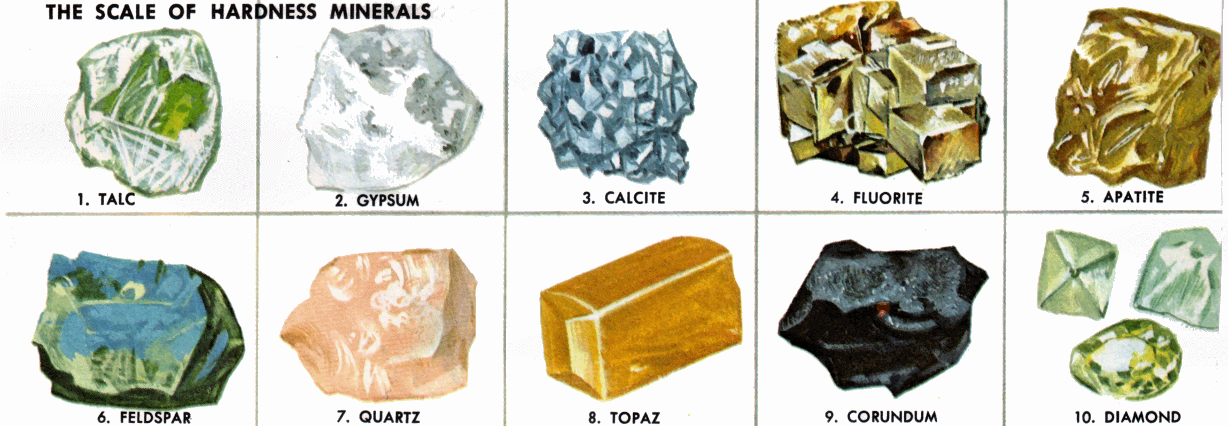
COLOR STREAK TEST
Some rocks make a streak of color when rubbed against a piece of tile or paper.
Others do not. The color of the streak is usually different than the color of the rock.

ACID TEST
Some rocks contain calcium. These rocks will fizz in the presence of acid as a gas is released during the reaction.

MAGNETISM
Some rocks contain metals that will attract a magnet.

Materials
Rock samples | Acid | Dropper | Paper
Magner | Coin | Nail | Safety glasses

Method

TEST ONE: HARDNESS

1. Select 5 rocks from the collection.
2. Try to scratch one with the other. The harder one will scratch the other.
3. Keep the harder rock. Choose another rock from the collection and do the scratch test between the two rocks. Keep testing until you find the hardest rock in your sample.
4. Continue the scratch test until you have all your rocks lined up from hardest to softest.
5. Test the rocks with other objects.

fingernail = 2.5 penny = 3.0 nail = 5.0

6. Complete your results table by numbering your samples from softest to
hardest. (Softest being #1 and hardest #6)

TEST TWO: COLOR STREAK TEST

1. Try to make a streak on the paper with the rock.
2. Record the colour of the streak in your results table.

TEST THREE: ACID TEST

1. Place the rock sample on the bench.
2. Place 5 drops of acid onto the sample.
3. Observe the rock for fizzing or bubbles.
4. Record the results in your table.

TEST FOUR: MAGNETISM

1. Select one of the rocks and touch it with the magnet.
2. Is the rock attracted by the magnet?
3. Record your results in your table.

Use your table, research skills and previous knowledge to try and classify each of your rocks.

Extension: Calculate the density of each of your samples when you have identified them

Results

Rock sample | Hardness number | Color of streak | Acid Test | Magnetism | Type of rock

References

