Session 5: | MODELING THE GREENHOUSE EFFECT

Assessed criteria

Criterion C: Processing and Evaluating (Formative)
Criterion E: AIE

Research Question
“How does the Greenhouse effect impact different places around the world?”

Background Information

A greenhouse works by letting in the heat and light energy from the Sun but then preventing it from leaving again so that the temperature remains warm. The Earth´s atmosphere works in a similar way. It allows the Sun´s energy to pass through but then prevents most of it from escaping. Without the atmosphere, the energy would be lost back into space immediately.
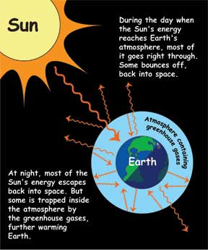
(Climatekids.nasa.gov, 2015)

Certain gases are very good at absorbing the heat energy from the Sun so we call them greenhouse gases. The most important greenhouse gases are:

Water (H2O)
Carbon dioxide (CO2)
Methane (CH4)

Each models in this experiment represents a different set of conditions in Earth’s atmosphere:
Model A is the control for Experiment 1. It represents Earth’s atmosphere as it would be without greenhouse gases to trap energy from the sun.
Model B has a cover that helps to capture energy from sunlight. The cover acts like greenhouse gases in Earth’s atmosphere.
Model C represents Earth’s atmosphere next to an ocean or other large body of water.
Model D represents the atmosphere over a dry area of land, like a desert.

- Hypothesis (Complete this section – What will happen to the air temperature in Model B? Will the presence of water produce results that are different from what happens in Model C? What will happen in model C? Why do you think this?)

Materials
5x beakers | 5x thermometers | 1x petri dish | Calcium chloride
Clear plastic | Heat lamp | Stopwatch | Digital balance

Method

The experiments use three different models for Earth’s atmosphere, as shown below, plus a control experiment.

D – Covered / Dry air
- Label 4 large beakers A – D
- Put 10g of calcium chloride into an open petri dish.
- Pour 100mL of water into small beaker.
- Prepare the beakers as shown in the diagram above.
- Record the initial temperatures of each thermometer.
- Place under the lamp record the temperatures every 5 minutes after turning the on the lamp.
- Record any observations of changes inside the beakers.
- Continue for 30 minutes and then turn the lamp off.
- Continue to take readings for 15 minutes.

Results

Table 1. Table to show the heating and cooling of Earth´s different surfaces (Complete this section)

 | Time (mins)
Model | 0 | 5 | 10 | 15 | 20 | 25 | 30 | 35 | 40 | 45
A
B
C
D
Graph (Staple your graph here – Make sure that it has title, labelled axes with units, data points and lines of best fit for each of the four lines)

Conclusion (Complete this section – A conclusion is used to compare your results to what you stated in your hypothesis)

Evaluation (Complete this section – An evaluation is used to describe any possible weaknesses in the method of your experiment and to suggest improvements.)

References

NASA Climate Kids (2017). What is the greenhouse effect?. Climatekids.nasa.gov. Retrieved 10 November 2017, from https://climatekids.nasa.gov/greenhouse-effect/

