Session 3: | Simple gas tests

Assessed criteria

Criteria E: AIE

Research Question

“How can we identify colourless, tasteless and odourless gases?”
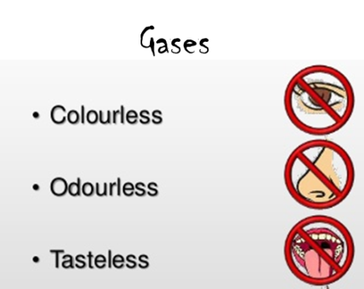
Background Information
All chemical reactions begin with reactants. These change permanently during a chemical reaction to form products. Lavoisier’s law or the ‘law of conservation of mass’, states that the mass should remain constant throughout a chemical process. We can tell a reaction is happening if we observe colour changes, effervescence or changes in temperature.

We can tell here that a reaction is taking place by the production of gases. Moreover, we can identify what gas is produced if we collect and test it.

We will be producing and testing 3 different gases: Oxygen, Hydrogen and Carbon Dioxide.

Objective
To perform different chemical reactions, carry out simple gas tests and be able to write balanced equations for each reaction.

Materials

1. Producing & testing H₂ | 2. Producing & testing O₂ | 3. Producing & testing CO₂ (demonstration only)
2 M hydrochloric acid | Hydrogen peroxide | Copper carbonate
1cm strips of magnesium | Small pieces of liver or potato | Bunsen Burner
2 mL pipette | 2 mL pipette | Pyrex test tubes (for heating)
Splint | Splint | Delivery tubes with bungs
Lighter | Lighter | Limewater
Test Tube | Delivery tubes with bungs | Balances
 | Test tubes | Weighing boats
 | Clamp stands | Splints
 | Clamps | Stand & clamps
Test tube rack

Safety (Complete this section)
This lab session has 4 hazards that we must consider to be able to carry out the experiment safely. Complete the table below to show you can work safely in the lab.

Chemical/equipment | Hazard symbol | What do you think hazard symbol means? | What will you do to reduce the risk of injury?
Acid | 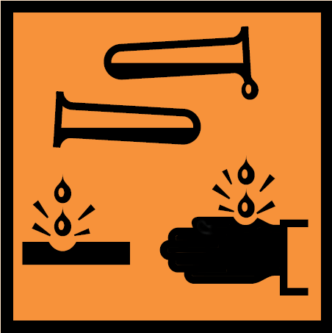
Copper chemical | 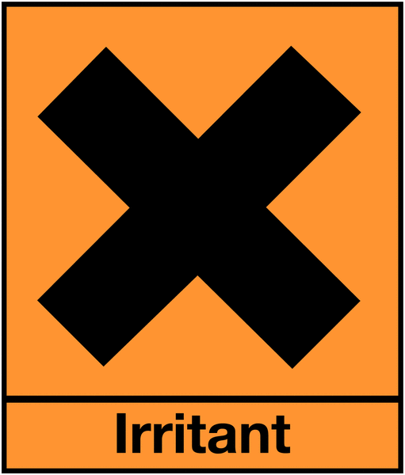
Magnesium | 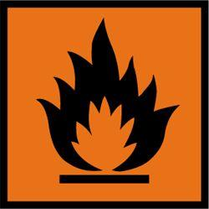
Bunsen burner | No symbol | ---------- | Wear safety goggles and tie up long hair

Method

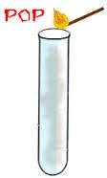
Stage 1 – Producing and Testing Hydrogen
Hydrogen can be liberated from hydrochloric acid when reacted with magnesium.
… HCl (aq) + …Mg (s) → …H₂ (g) + …MgCl₂ (aq)

- Balance the chemical equation
- Pour 2mL of 2M hydrochloric acid into a test tube.
- Add a small piece of magnesium to the acid in the test tube.
- Immediately put your thumb over the end of the test tube.
- Bubbles of hydrogen will be produced, and you will feel the pressure of the gas building up underneath your thumb.
- Bring a lit splint towards the top of the test tube.
- As soon as you move your thumb away, place flame at the mouth of the tube.
- You should hear a distinctive ‘squeaky pop’ sound.

Stage 2– Producing and Testing Oxygen

catalase
… H₂O₂ (aq) → … O₂ (g) + … H₂O (l)

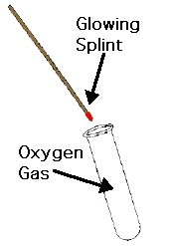
Liver and potatoes contain an enzyme called catalase which breaks down hydrogen peroxide (H₂O₂) into water and oxygen. Catalase acts quickly; one molecule of it can deal with six million molecules of hydrogen peroxide in one minute! This same reaction can be catalysed by iron. However, to achieve the same speed there would need to be about six tons of iron.

- Balance the chemical equation
- Pour 2mL of hydrogen peroxide into a test tube.
- Add a very small piece of liver or potato to the peroxide.
- You will immediately see effervescence.
- Light a splint and when it is burning well, blow it out. You need to have a glowing end on the splint.
- Put the glowing end into the test tube.
- If the gas given off is oxygen, it will cause the splint to relight.

Stage 3 – Producing and Testing Carbon Dioxide (demonstration only)

Metal carbonates decompose on heating to form metal oxides and carbon dioxide.
heat
… CuCO₃(s) → … CuO(s) + … CO₂(g)

However, copper carbonate is found as copper carbonate basic, and the reaction that takes place is:
heat
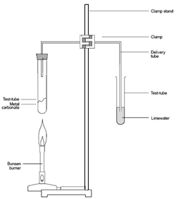
… CuCO₃· Cu(OH)₂(s) → … CuO(s) + … CO₂(g) + … H₂O (l)

- Balance the chemical equation
- Record the mass of a test tube.
- Measure roughly 3g of copper carbonate in a weighing boat; record the mass
- Transfer it to the test tube.
- Record the total mass of the tube and contents.
- Set up the equipment as shown on the right:

- Heat gently (on the weakest blue flame), for 5 minutes, or until you think it has finished reacting.
- Turn off the heat and allow contents to cool.
- Record the mass of the tube and its contents.

Results (Complete this section)
Table to show (….)

Reaction | Test | Gas produced

Questions
In stage 1 – explain why and how we feel pressure under our thumb as the gas is produced (think about the molecules in the gas):

……………………………………………………………………………………………………………………………………………………………………………………………………………………………………………………………………………………………………………………………………………………………………………………………………………………………………………………
In stage 2 – explain how this knowledge can help us prevent house fires from spreading. (think about what the oxygen caused the flame to do):

……………………………………………………………………………………………………………………………………………………………………………………………………………………………………………………………………………………………………………………………………………………………………………………………………………………………………………………

