Session 6: | DENSITY OF SEA WATER I

Assessed criteria

Criteria C: Processing and Evaluating

Criteria E: AIE

Research Question

“How can I identify where a sea water sample come from?”

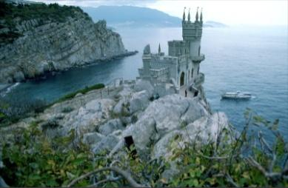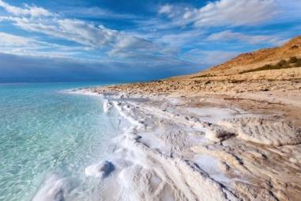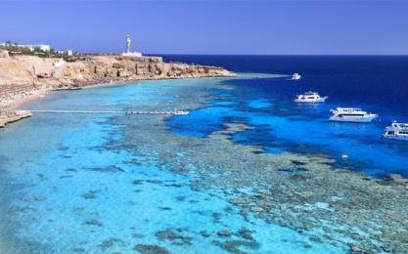
Black Sea (Ukraine, 1987) Dead Sea (Israel, 2013) Red Sea (Egypt, 2011)

Background Information
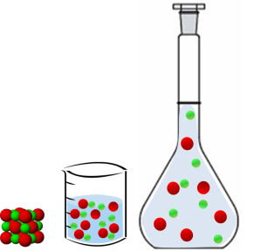
When we dissolve a solid in a liquid, the solution produced may have a different density to the original liquid. This is because there is now a different amount of matter, in a different volume. Different seas have different amounts of salts dissolved in them, depending on where they are, and their size.

The concentration of the solution depends on how much solute (solid) is dissolved into the solvent (liquid). On the other hand, the density of a solution depends on which is the weight of a certain volume of that solution. Concentration and density are therefore related, and we can use this fact in the lab to help us to identify different samples.

Objective
We have four samples of sea-water from around the world. You are going to produce a graph to show the relationship between concentration and density of a solution and then (in the next session) use the graph to identify where the samples were taken.

Hypothesis (Complete this section)
As the amount of salt increases, the density …………………………………………………………………………. …………………………………………………………………………………………………………………………………………………………………………………………………………………………………………………………………..…………………………………………………………………………………………………………………………………………….… .
Materials
250 mL volumetric flask | Spatula | Pipette
250 mL measuring cylinder | Paper | Millimetre paper
Densimeters | Water | Ruler
NaCl (common salt) | Electronic scale

Method
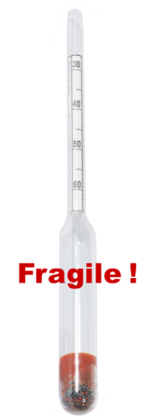
After being shown how to read the units on a densimeter, you will prepare some of the six solutions of given concentrations of NaCl, in pairs. You will then measure their densities with a densimeter. Your teacher will tell you which of the solutions to prepare:
Solution you will prepare | Concentration (g/L)
5 g/250 mL | 20
10 g/250 mL
15 g/250 mL
20 g/250 mL
25 g/250 mL
30 g/250 mL

To prepare the solutions, follow these steps:
- Carefully measure the corresponding mass of NaCl on a balance.
- Pour the salt into the flask, taking care not to spill any.
- Pour distilled water into the flask (it should NOT reach the line on the neck of the flask).
- Invert the flask, until the solid has completely dissolved.
- Precisely fill the flask with water, using a pipette.
- Make sure the meniscus sits exactly on the top of the line.
- Pour the contents of the flask into a 250mL measuring cylinder.
- Put the densimeter into the cylinder and record the density value. You have four densimeter for different ranges of densities: 0.9-1.0 g/ml; 1.0-1.1 g/ml; 1.1-1.2 g/ml; 1.2-1.3 g/ml. If you do not have an idea about the density of your solution, it is better to try the one with lower densities first.
- Rinse the glassware and then repeat steps 1-8 with the other solution you need to prepare.

Results

Table

(Write your results here – Make sure that it has title and headings with units)

Graph

(Insert your graph here – Make sure that it has title, labelled axes with units, data points and lines of best fit for each of the three lines)

