Rocks and weathering
Name _____________________________ Class ______

Complete the following paragraphs, using words from the boxes.

1 Both _________________ rocks and those used as _________________ materials become ____________ over time. The _________________ up and _________________ away of rocks is called _________________ and it happens in several different ways.

Some examples are shown below.

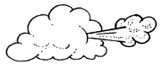 | 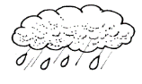 | 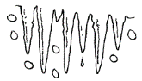
Weathering by  ________________________ . | Weathering by  ________________________ . | Weathering by  ________________________ .
breaking building changed freezing natural rain wearing
weathering wind

2 The bits of rock are then _________________ away by streams and _________________ This is called _________________ . As the rocks are washed along they are _________________ up into _________________ pieces. The smallest bits of rock are called sand and _________________ . Eventually, the water flow _________________ down and the sand, clay and gravel are. This is called _________________ . The bits of rock formed by _________________ and erosion that are not washed out to sea become a home for _________________ and tiny animals. Eventually soil is formed.

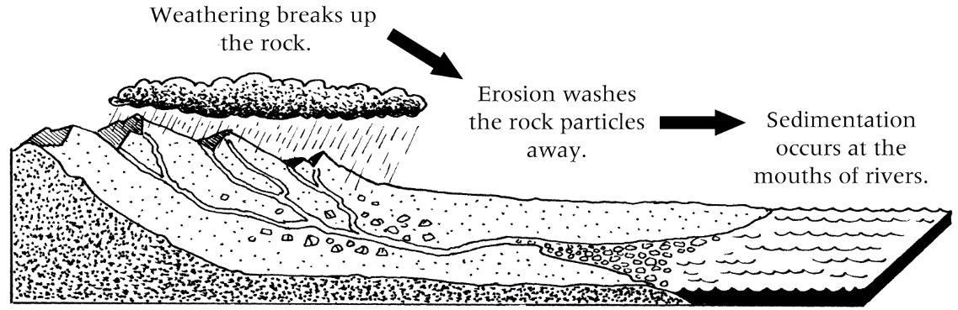
Sedimentation.

broken clay deposited erosion plants rivers
sedimentation slows smaller washed water weathering

