Laboratory | Flowers and Plant Reproduction

Assessed criteria
Criterion E:

Background Information
Angiosperms and Gymnosperms are both flowering plants with vascular tissue. Flowers are the reproductive organs in flowering plants. During sexual reproduction in plants two sex cells (gametes) are involved. The gametes are produced inside the flower, the male gametes are in the pollen of the flower, while the female gametes are in the ovary of the flower. After fertilization seeds develop, growing into a new plant. .
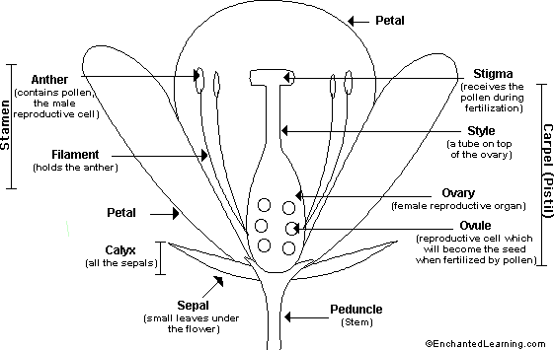
(Enchantedlearning.com, 2017)

Most flowers are hermaphrodites, they consist of male and female parts. The male parts of the flower are the Anther and Filament, known together as the Stamen. The female parts or Carpel are the stigma, style, ovary and ovule.
Pollination happens when the pollen from the male part of the plant is transferred to the Stigma (female part of the plant). For 80% of flowering plant species a biotic agent is responsible for carrying the pollen from one flower to another. These are usually insects, but sometimes birds (for example, humming birds) or mammals (for example bats). Flowers are adapted to enable pollination by either of these ways.

Have a look at this video to see how thew structure of the flower facilitates pollination.

Objective

Identify the parts of a flower and recognise whether a flower is pollinated by an insect or the wind.

Materials

Hand lens | Dissecting kit
White paper | Flowers
Microscope | prepared slides
Ruler | White tile

Safety
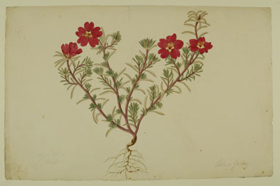
Take care with scalpels. Always carry them held tightly, with the blade pointing away from the body and other people.

Method

Part 1

Collect 1 flower from a plant, be careful to remove it properly from the stem.
- On your blank paper sketch the flower and label any parts you recognise. (botanical sketches like the one shown here, are a very useful way to identify plants)
(The Dapuri Collection )

- Carefully using a scalpel cut the the flower to show the carpel (usually central, with the sticky stigma at the top, and the style leading down to the ovary), stamens (with anthers attached), petals, and sepals. Your teacher will show you how best to do this

Set out the different parts on a clean piece of white paper
- Draw and label the internal parts of the flower, you may use a hand lens to see the structures clearly.

- Decide whether your flower is insect or wind pollinated

Part 2

Using the pictures on the attached presentation decide if these flowers are pollinated by insects or the wind, make sure you can explain why.

https://docs.google.com/presentation/d/18hycVFtBfgak29qkNCeY9rhlc2rEq64bfm97Zg5DyrY/edit?usp=sharing

Complete the table comparing the characteristics of wind-pollinated flowers with those of insect-pollinated ones

Wind pollinated | Insect pollinated

Part 3

Using a microscope look at the ovary and pollen from different flowers and draw a detailed diagram of what you see.

Extension

- Describe and explain the differences between self and cross pollination.

- Explain how seed dispersal is different to pollen dispersal.

References
Enchantedlearning.com. (2017). Flower Anatomy Printout - EnchantedLearning.com. [online]
Available at: http://www.enchantedlearning.com/subjects/plants/printouts/floweranatomy.shtml [Accessed 21 Mar. 2017].

Nuffieldfoundation.org. (2017). Comparing the flower structure of different angiosperms | Nuffield Foundation. [online] Available at: http://www.nuffieldfoundation.org/practical-biology/comparing-flower-structure-different-angiosperms [Accessed 21 Mar. 2017].

Mitchell, L. (2017). Royal Botanic Garden Edinburgh - Image collections. [online] Rbge.org.uk. Available at: http://www.rbge.org.uk/science/library-and-archives/image-collections [Accessed 21 Mar. 2017].

