- Order the following elements by increasing electronegativity: C, Fe, Cl, Ca.

- Define the following concepts:
- Electronegativity

- Metallic bonding

- Describe Thompson´s model of the atom.

- State the full electron configurations of: H (Z=1), P (Z=15) and Fe³⁺ (Z=26)

- Indicate which of these sets of quantum numbers is allowed:
(2,1,0,1/2) (1,1,0,-1/2) (3,2,-2,1/2) (4,1,2,1/2)

- Describe and explain the trend in ionization energies in the periodic table.ht, 5s – 4d – 5p, named after the sublevels filled in taking into account minimal

- State the postulates of Bohr’s atomic model.

- Explain, giving reasons, which is the type of bonding that will be developed more likely between the following couples of chemical elements:
- Ti (electronegativity EN=1.5) and O (EN=3.5)

- S (EN=2.5) and O (EN=3.5)

- These are the electronic energy levels of an atom (“n=1” is the first energy level and so on…). Draw and label one emission electronic jump and one absorption jump. State whether the jumps you have drawn are of the same energy or different energy.
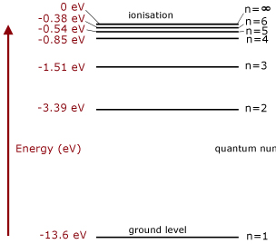

- Helium (He) was first discovered as an element found in the Sun. After observing in an atomic spectrum of sunlight scientists saw set of lines on an emission spectrum that did not correspond to any of the known chemical elements. Explain how they came to this conclusion.

- On the basis of the knowledge acquired about the relationship between bonding and substances properties, design a procedure to classify a set of unknown substances by their type of bonding. Indicate the tests/experiments you would do and what their possible results would mean.

- The red line represents the Group 16 elements bonded with hydrogen. Explain why the boiling point increases from H₂S to H₂Te and explain why H₂O does not fit this trend.
The blue line represents the halogen halide molecules. Explain why does HF not fit the pattern?
