NATURAL SCIENCES DEPARTAMENT | Unit 7 practice exam  Physics and Chemistry 10º
Name and surname
Date ____________________ Mark. A_____. B_____. MYP_____. VC_____._____.
- State Newton´s 1st law.

- Show which of the following produces the greatest pressure: 8 N on 2 m², 200 N on 20000 cm² and 50 N on 0.5 m².

- Label the following forces acting on the diagram below – gravity, normal, centripetal and friction.

- State the equation for the law of universal gravitation and describe how it relates mass and distance to force.

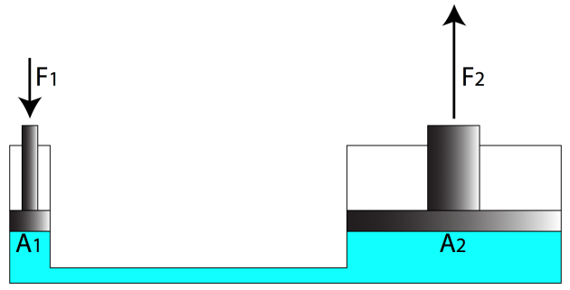
- The hydraulic system below is set up to lift a car with a mass of 500 kg on piston 2. Calculate the minimum force required at F₁ to lift the car if A₁ = 0.5 m² and A₂ = 4 m².

- A standard mercury barometer at sea level supports 760 mm Hg in a column with a cross sectional area of 1 cm². Explain what would happen if the barometer was taken to the edge of the Dead Sea (no tinto the water) which has an altitude of 400 m below sea level.

- Calculate the difference in hydrostatic pressure felt by a submarine at a depth of 200 and 400 m respectively. Data: d_{sea water}=1030 kg/m³

- A 600 kg car accelerates uniformly from rest for 30 seconds and reaches a speed of 120 m/s. It then collides with a tree. Calculate the force applied by the car hitting the tree.

- The graph below shows data collected from a Hooke´s law invesitgation. State the equation for Hooke´s law and use it to calculate the extension constant, k.

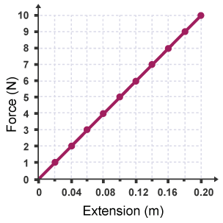

- Explain why liquids are more suitable in their use in hydraulic systems than gases and solids.

- A cube of material X is placed in a container of distilled water. Half of the cube remains above the surface of the water as it floats. Calculate the mass of the cube. Data: d_{distilled water}=1 g/cm³; cube side length = 2 m.

- The table below gives data about “ratios compared with Earth”. Compare and explain the similar values seen for force due to gravity on Venus and Saturn.

Formulation
- Potassium permanganate
- Sodium hydroxide
- Calcium phosphate
- Lead(II) iodide
- Sulfuric acid
- Beryllium oxide
- Sodium nitrite
- Zinc(II) arsenate
- Iron(III) sulfite
- Ammonia

- LiCN
- Mg(IO₄)₂
- Fe(NO₃)₂
- Zn(SCN)₂
- CH₄
- HBr
- Mn(OH)₂
- Na₃BO₃
- PdS
- Au₂O

