NATURAL SCIENCES DEPARTAMENT | Unit 7 practice exam  Physics and Chemistry 10º
Name and surname
Date ____________________ Mark. A_____. B_____. MYP_____. VC_____._____.
- State Newton´s 1st law. 0.3 for each: an object will remain at rest; or with a constant velocity; unless acted on by a force.
- Show which of the following produces the greatest pressure: 8 N on 2 m², 200 N on 20000 cm² and 50 N on 0.5 m². 0.3 for each: 8/2=4 Pa; 200/2=100 Pa; 50/0.5=100 Pa
- Label the following forces acting on the diagram below – gravity, normal, centripetal and friction. Gravity down, normal up, friction right and centripetal from edge of a wheel to centre. 0.3 for 2 correct; 0.6 for 3 correct; 1 for 4 correct.
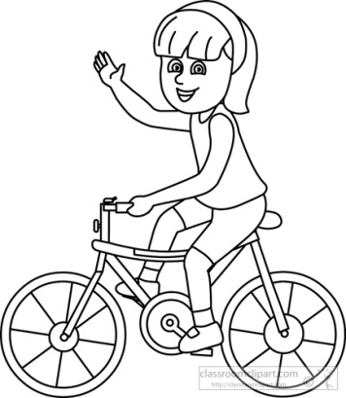

- State the equation for the law of universal gravitation and describe how it relates mass and distance to force. F=(G·m1·m2)/d²; F directly proportional to m; F inversely proportional to d².
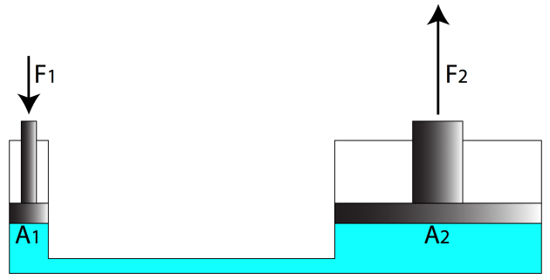
- The hydraulic system below is set up to lift a car with a mass of 500 kg on piston 2. Calculate the minimum force required at F₁ to lift the car if A₁ = 0.5 m² and A₂ = 4 m².
F1/A1=F2/A2;
Weight of car=500·9,8=4900 N;
F1=(4900·0.5)/4=612.5 N

- A standard mercury barometer at sea level supports 760 mm Hg in a column with a cross sectional area of 1 cm². Explain what would happen if the barometer was taken to the edge of the Dead Sea (no tinto the water) which has an altitude of 400 m below sea level. Height of Hg would increase; greater atmospheric pressure; would be able to support a greater weight of mercury.
- Calculate the difference in hydrostatic pressure felt by a submarine at a depth of 200 and 400 m respectively. Data: d_{sea water}=1030 kg/m³ p1=h·d·g=200·1030·9,8=2018800 Pa; p2=400·1030·9,8=4037600 Pa; 4037600-2018800=2018800 Pa (must have units for final answer)
- A 600 kg car accelerates uniformly from rest for 30 seconds and reaches a speed of 120 m/s. It then collides with a tree. Calculate the force applied by the car hitting the tree. F=m·a; a=(120-0)/30=4m/s²; F=600·4=2400 N
- The graph below shows data collected from a Hooke´s law invesitgation. State the equation for Hooke´s law and use it to calculate the extension constant, k.
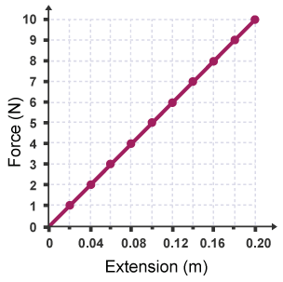
F=k·x
Gradient=k=10/0.2=50
Units = N/m

- Explain why liquids are more suitable in their use in hydraulic systems than gases and solids. Gases can be easily compressed; solids particles in fixed positions so cannot move freely; liquids are closely packedbut can still move freely.
- A cube of material X is placed in a container of distilled water. Half of the cube remains above the surface of the water as it floats. Calculate the mass of the cube. Data: d_{distilled water}=1 g/cm³; cube side length = 2 m.V_{object displacing water}=1/2 ·(2·2·2)=4 m³; F_{object}=F_{thrust}=4·1000·9,8=39200 N; m=F/a=4000 kg
- The table below gives data about “ratios compared with Earth”. Compare and explain the similar values seen for force due to gravity on Venus and Saturn. Very similar values; although Saturn has a very high mass BUT diameter of venus is much smaller; density of venus much smaller.

Formulation
- Potassium permanganate
- Sodium hydroxide
- Calcium phosphate
- Lead(II) iodide
- Sulfuric acid
- Beryllium oxide
- Sodium nitrite
- Zinc(II) arsenate
- Iron(III) sulfite
- Ammonia

- LiCN
- Mg(IO₄)₂
- Fe(NO₃)₂
- Zn(SCN)₂
- CH₄
- HBr
- Mn(OH)₂
- Na₃BO₃
- PdS
- Au₂O

