Session 5: | Gummy bear surgery

Assessed criteria
Criterion B: Develop practical skills

Criterion E: AIE

Research Question
“How do surgeons describe what they are doing?”

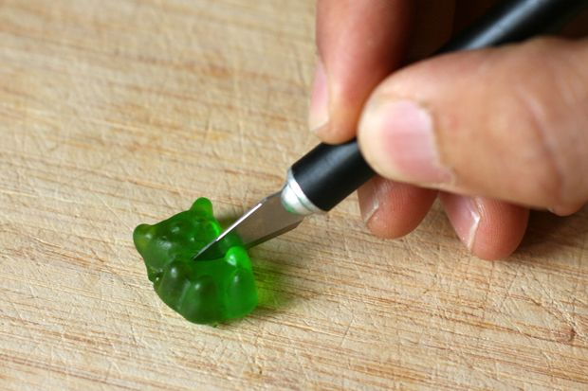
Background Information
Gummi Bears live short lives, but that does not mean that they don't have health problems and will occasionally need some care. There are times when these delicate bears will even need to have surgery.
The very substance of the Gummi Bears is tricky stuff and if you want to be able to identify a tumour and have it removed or transplant a brain, you need experience in using anatomical words and tools.

The Language of anatomy

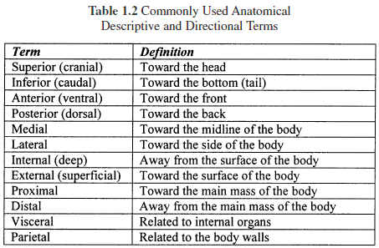
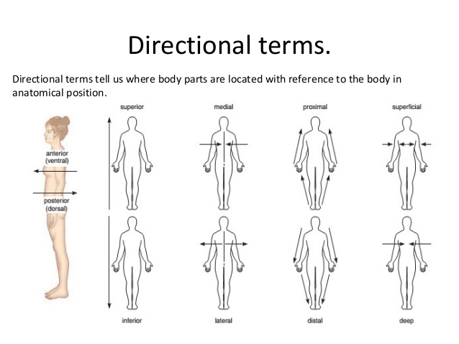
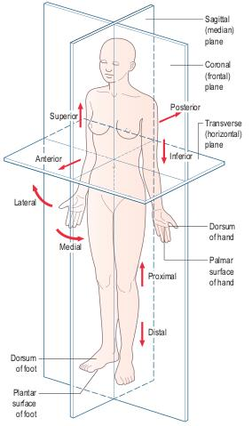
Objective
To gain confidence using dissection tools and be able to apply anatomical planes and directional terminology.

Materials
- 1 small banana per pair
- 15 – gummy bears per pair of students
- 1 – razor blade /scalpel per pair of students
- 2 – small tweezers
- 1 – sheet of A4 white paper (dissection surface) per pair of students
- 1 – hard surface (tile or tray) to do the cutting on
- Pens
- Transparent tape
- Results sheet to stick the completed bodies on

Procedure

DO NOT EAT ANY FOOD IN THE LABS
Working in groups of two, only one person at a time can do the cutting

Part 1 Warm up
- Draw one small circle and two ovals onto the banana. These represent tumours.
- Carefully, without damaging the fruit body underneath, remove the tumours using the blade and tweezers.
- Turn the banana over and repeat for the other person in the group.
Elliptical and circular incisions to remove skin tumours

Part 2 Dissections
- Using the anatomy guide in the background information, cut the gummy bear into different sections.
- Stick the correct sections on a sheet and label them.
- On a separate sheet draw a diagram of the resultant dissections.

- Dorsal & ventral surfaces
- Anterior and posterior views
- Cranial & caudal portions
- Place Gummi on its legs, like a four-legged animal stands. Cut one of the legs into proximal and distal portions.
- Place Gummi on its legs, like a four-legged animal stands. Cut along the transverse plane to divide into cranial and caudal parts.
- Place Gummi on its side, like a four-legged animal lying down. Cut along the frontal plane to divide into dorsal and ventral parts.
- Place Gummi on its legs, like a four-legged animal stands, and place it in an anterior view facing you. Cut it along the median plane to break into equal, symmetrical right and left halves.
- Place Gummi on its legs, like a four-legged animal stands, and place it in an anterior view facing you. Cut along any sagittal plane except the median plane to divide it into unequal right and left halves.

Part 3 Transplants
Heart
- Select one Gummi to be the donor
- Cut out a heart shape from the chest.
- Empty the ventral chest cavity of the recipient
- Place the donor heart into the cavity of the recipient.
Brain
- Obtain a brain from a donor. The donor is dead so the top of his skull can be removed.
- Empty the cranium of the recipient Gummi. Take care to NOT remove the top of the head.
- Place the brain into the recipient.
- Close the top of the skull.

Results (Stick the completed surgeries on your results sheet an take a photo to paste here)

References
Organic bench model to complement the teaching and learning on basic surgical skills http://www.scielo.br/scielo.php?script=sci_arttext&pid=S0102-86502012000100015

Gummy Bear surgery. http://www.instructables.com/id/Gummi-Bear-Surgery/

STUDENT SHEET

- Dorsal & ventral

- Anterior and posterior

- Cranial & caudal

- Proximal and distal 5. Transverse plane

6. Frontal plane 7. Median plane

8. Sagittal plane.

