Session 12: | MODELING PHOTOSYNTHESIS

Assessed criteria
Criterion B: Planning an investigation (Formative)

Criterion C: Data Processing (Summative)

Research Question
“How can we model the factors that affect the rate of photosynthesis?”

Introduction

We can use virtual experiments to model the effects of factors in experiments that have been repeated many times, and scientists are confident of predicting the results. An aquatic plant (elodea) has been tested rigorously and how it photosynthesizes is well understood. Scientists use the following apparatus:
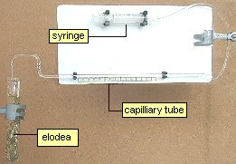
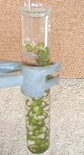

You can access a copy of the virtual experiment from:

http://www.kscience.co.uk/animations/photolab.htm

If you click on Photosynthesis, you can vary:
- The light level by moving the lamp with the mouse.
- The temperature by using the scrollbar.
- The CO2 concentration by using the scrollbar.

You will choose 1 factor to investigate.

Planning your experiment:

Decide which of the variables you are going to investigate and how you can ensure that your experiment is a "fair test".

You must then decide the range over which you are going to make measurements and how many measurements you should make. e.g. if you were varying the temperature, should you make measurements every degree, every 5 degrees, every 10 degrees etc?

In this experiment you measure the total volume of oxygen produced in a measured time interval using the syringe to move the bubble.

Making a hypothesis

Try to make a prediction of what your results will show. e.g. if you were planning to change the light intensity, would you expect the rate of photosynthesis to increase or decrease with an increase in light intensity?

You should also try to give a scientific reason for your prediction.

Processing your data

Usually, the best way to display your data is in the form of a graph. (remember that all graphs should have titles and the axes should have labels and units). The points you should cover are:

Do your results support your prediction ?

Are there any trends or patterns in your results ?

Use the following headings:

Background Information

Hypothesis

Materials

Method

1.
2.

Results

Conclusion (Complete this section – A conclusion is used to compare your results to what you stated in your hypothesis. Try to add scientific vocabulary and reasons for your observations from your references)

References

