Session 1 | INTRODUCTION: LAB MATERIALS AND MEASUREMENT

Assessed criteria
LAB SKILLS:
- Identify equipment
- Take accurate measurements
- Draw table of results

Criteria C: Processing and Evaluating (Formative)

Criteria E: AIE

Research Question
What is the best way to measure our observations?
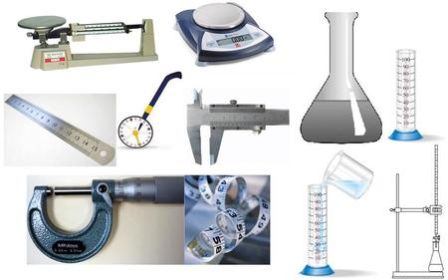

Background Information
While you've probably measured many things, you may not be familiar with some of the scientific instruments that help us measure length, volume, mass, and time. Measuring in science is a lot like measuring in the everyday world, but with a little more detail and some unique instruments. This lesson will explore some common and not so common scientific instruments to help you understand the world of scientific measurement.
All measurements must have a standard. A standard is an exact quantity that people use for comparison. This means that two people using the same instruments should get the same results. In the past people used to use body parts or everyday objects as a standard of measurement.
So now scientists use the International System of units (SI), which uses, among others, the following units:
- Meter (m) for length
- Kilogram (kg) for mass
- Cubic meter (m³) for volume
- Second (s) for time
Objective
To understand that in order to obtain accurate measurements you must use precise measuring instruments.
To start to understand the difference between accuracy and precision.

Materials

A pencil case | Measuring cylinders (100 mL, 10 m)
Container with blue dyed water  Container with green dyed water | Beakers (250 mL, 100 mL)
Unmarked masses  Weights | 2 Small empty containers
Rulers (30 cm)  Tape measure | Various Sand timers or burette filled with water
Electronic balance  Mechanical balance | A stopwatch

Method ( Work in pairs)

Record your results in the corresponding table as you take each measurement.

Measurement 1: Length of a pencil case

- Measure the length of the pencil case using your hand and fingers. Write the answer in handspan.
- Have your partner do the same. (a. How similar are the two measurements?)
- Measure the length of the pencil case using a ruler. Have your partner do the same. (b.How similar are the two measurements?)
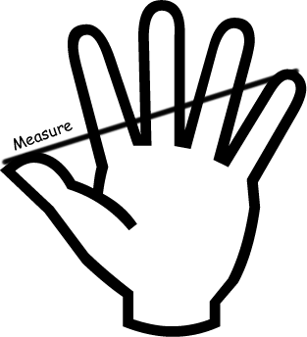
- Use the ruler to measure your handspan.
- Use your handspan to measure the height of your partner. Write the answer in cm.
- Measure the height of your partner with the ruler. Write the answer in cm.
(c. How close are your two measurements?)

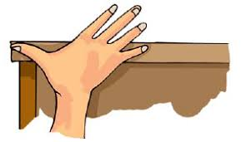

Measurement 2 : Volume of two different liquids

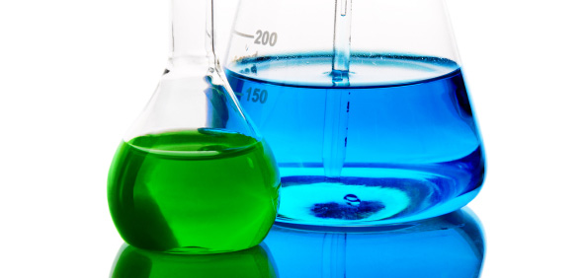
Plastic pipette and measuring cylinder
Large beaker, small beaker and measuring cylinder
You have a large volume of blue liquid and a smaller volume of green liquid in beakers or other glass container.

1. Measure the volume of the blue liquid using the 250 mL beaker.
2. Measure the volume of the blue liquid with the 100 mL beaker.
3. Measure the volume of the blue liquid with the100 mL measuring cylinder.

4. Measure the volume of the green liquid using the plastic pipette or dropper. You will need to place the green liquid in the empty container until you have finished measuring all of it.
5. Measure the volume of the green liquid using the 10 mL measuring cylinder.

(d. Which glassware should be used to measure liquid volumes? Give reasons.)

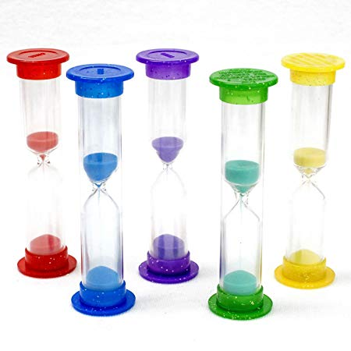
Measurement 3. Time for a container to empty

1. Set up a sand timer or burette filled with water.
2. Time how long it takes to empty using your pulse.
3. Time it again with a stopwatch.

(e. Which is more reliable, why?)

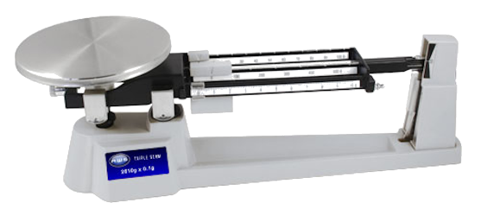
Method 4. Mass of 2 unknown objects.
- Pick up one of the objects in one hand.
- With the other hand pick up a marked mass or weight and compare the two.
- Estimate the mass of the object.
- Have your partner do the same.
- Measure the mass of the object with the mechanical balance.
- Measure the mass of the object with the electronic balance.
- Repeat with the other object.
(f. How close were your estimates to the final answer?)
(g. Which balance gives you a more precise reading? Give reasons.)

RESULTS

Experiment 1

Table 1. _________________________________________________________

 | Measuring instrument
Object | Your Handspan | Your partner’s Handspan | Your Ruler  (unit……) | Partner’s Ruler  (unit……)
Pencil Case

Student 1

Student 2

Length of your handspan ________________________

Length of your partner’s hanspan ____________________

Experiment 2

Table 2. ____________________________________________________________

 | Measuring instrument
Liquid | 250 mL beaker  (……) | 100 mL beaker  (……) | 100 mL measuring cylinder  (……) | 10 mL Measuring cylinder  (……) | Plastic Pippette  (……)
Blue |  |  |  |  | X
Green | X | X

Experiment 3

Table 3. ____________________________________________________________

 | Measuring instruments
 | Pulse 1st Person | Pulse 2nd Person | Stopwatch 1st Person  (……) | Stopwatch 2nd Person  (……)

Experiment 4

Table 4. ____________________________________________________________

 | Measuring instrument
Object | Estimated mass  (…….) | Mechanical balance  (…….) | Electronic Balance  (…….)

Conclusion

1. Answer the questions in green.
2. What problems can happen if you use the wrong instruments when taking measurements?
3. Why do we need to use standard measuring instruments?
4. What does it mean when we say that a measuring instrument is more precise than another?
5. Precision and Accuracy are often confused and used as synonyms however, they have very different meanings. Define each one and make sure you understand the two!

Challenging question:

Precision in Science and experimentation has another important meaning you will need to understand but we have not yet explained. Go out and do some research see if you can help us with this!

