Session 2: | HEATING THE EARTH

Assessed criteria

Criterion C: Processing and Evaluating (Formative)

Criterion E: AIE

Research Question
“How do the different surfaces on Earth affect the local climates?”

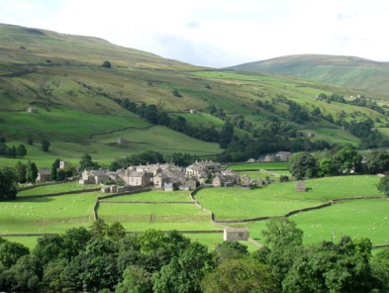
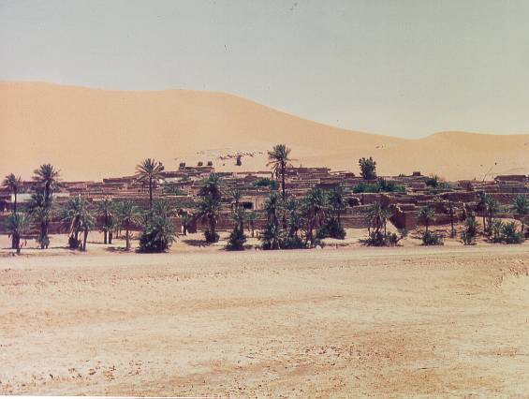
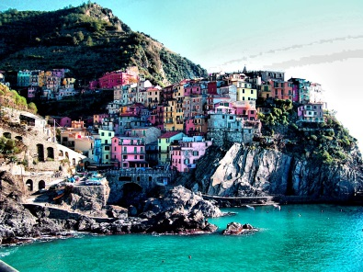
(Treks.org, 2015) (Talkspot, 2010) (Lamountaineers.org, 2015)

Objective
To model the heating and cooling of three different surfaces of Earth using sand, water and earth.

Background Information
In general, coastal areas have quite low differences between their daytime temperatures and night-time ones. This is because water absorbs the Sun´s energy slowly during the day and then releases it slowly during the night.

In the desert, there can be very large differences between day and night time. For example, in the Sahara desert, the temperature can vary between -1 and 45 ºC! (HowStuffWorks, 2015)

Rural towns that are found in areas of land that consist mainly of earth normally have temperature variations somewhere between the two examples above.

Hypothesis (Complete this section)
The material that will heat and cool the slowest will be ……………………….. and the material that will heat and cool the fastest will be ………………………… . I think this because in the background information section it says that ………………………………………………………………………………………………… …………………………………………………………………………………………………………………………………………………..…………………………………………………………………………………………………………………………………………….… .

Materials
- 3 x 250mL beakers
- 3 x thermometers
- Heat lamp
- 150 mL water
- 150 mL sand
- 150 mL potting soil
- Stopwatch
- Safety goggles

Method
- Fill each beaker with 150 mL of each substance. Lightly tap the soil and sand to remove pockets of air. (1. Are beakers the most accurate piece of equipment for measuring volumes?)
- Place the thermometers upright into the beakers and take the initial (starting) temperature. (2. Are the thermometers in the same place in each beaker?)
- With the lamps off, place the beakers under the heat lamp so that they all get the same amount of light. (3. Are they all receiving exactly the same amount of light?)
- Complete the table: Turn the light on and measure the temperature of each substance every 5 minutes. (2. Is it possible to record all 3 at the same time?)
- Record the temperature in the table below.
- After 20 minutes, turn off the light.
- Continue to record the temperature at 5 minute intervals for 20 minutes more.
- Draw a graph of your results. Your graph will have 3 lines. One for each surface. (For extra help see “how to draw a great graph” on the web site *)
- Complete the conclusion and evaluation.

Results

Table 1. Table to show the heating and cooling of Earth´s different surfaces (Complete this section)

Time (mins) | 0 | 5 | 10 | 15 | 20 | 25 | 30 | 35 | 40
Temperature of water (ºC)
Temperature of sand (ºC)
Temperature of soil (ºC)

Graph (Staple your graph here – Make sure that it has title, labelled axes with units, data points and lines of best fit for each of the three lines)

Conclusion (Complete this section – A conclusion is used to compare your results to what you stated in your hypothesis)

The surface that heats up the fastest is …………………….. and the material that cools down the fastest is …………………… . The surface that heats up the slowest is …………………….. and the material that cools down the slowest is…………………………… . These results match/do not match what I stated in my hypothesis because …………………………………………………………………………………… ……………………………………………………………………………………………………………………………………………….. .

Evaluation (Complete this section – An evaluation is used to describe any possible weaknesses in the method of your experiment and to suggest improvements. Look through the method and answer the blue questions below. Suggest an improvement for each one. The first one has been done as an example.)

(Blue question 1) One problem in the method is using a beaker to measure the volumes of each material. A beaker is not the most accurate piece of equipment for measuring volume. To improve this we could use a measuring cylinder.

(Blue question 2) Another problem is that…

(Blue question 3) There is a possible error in step 3 that…

(Blue question 4) We could improve step 4 because…

References

HowStuffWorks,. (2015). The Sahara Desert - Climate - HowStuffWorks. Retrieved 6 July 2015, from http://geography.howstuffworks.com/africa/the-sahara-desert3.htm

Lamountaineers.org,. (2015). "Walk Across England, Fall of 2009", by Dick and Judy Opsahl. Retrieved 6 July 2015, from http://lamountaineers.org/Programs/Program_05-19-10.html

Talkspot,. (2010). Roberta Owen. Retrieved 6 July 2015, from https://talkspot.wordpress.com/author/talkspot/page/2/

Treks.org,. (2015). Sahara desert hotel. Retrieved 6 July 2015, from http://www.treks.org/algerenglish.htm

