Session 2 | Measuring Liquids

Assessed criteria
LAB SKILLS:
- Take accurate measurements
- Use of glassware

Criteria C: Processing and Evaluating (Formative)

Criteria E: AIE

Research Question
How can we decide which measuring instrument to use?
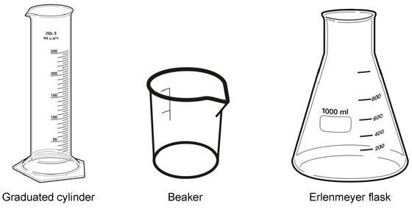

Objective
To obtain an accurate measurement of volume.
To practice reading scales accurately.

Materials
Blue dyed liquid | Measuring cylinders
Green dyed liquid | Beakers
Dropper pipettes | Burette
Test tube holder
Test tubes

Background Information
In science, the instruments for measuring the volumes of liquids are generally made from glass, plastic or occasionally metal, although scientists usually refer to all of them as “glassware”. Chemists have a variety of glassware at their disposal for measuring volumes. The specific piece of glassware chosen in any situation will depend mainly on two factors:
- The volume you need to measure.
- The accuracy needed for the measurement.

In the lab we use millilitres (ml) to measure volume. Measuring liquids can be difficult, it takes practice and skill to measure with the different instruments.
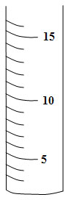
1. First look at the scale and calculate the value of the smallest divisions.

In this cylinder the smallest measurements are each 1ml

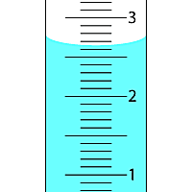

In this tube the smallest measurements are 0.1ml

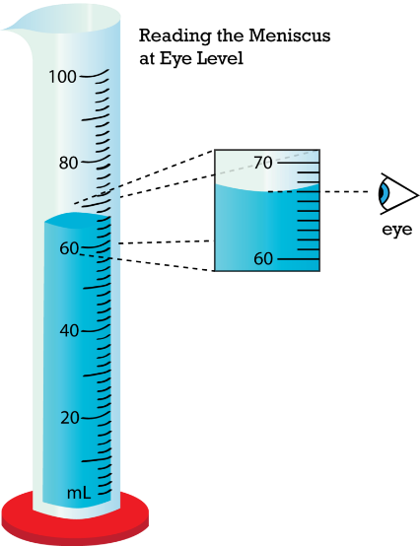
2. Read the measurement from the bottom of the meniscus.

Measurement 1: Measuring the same volume with different instruments.
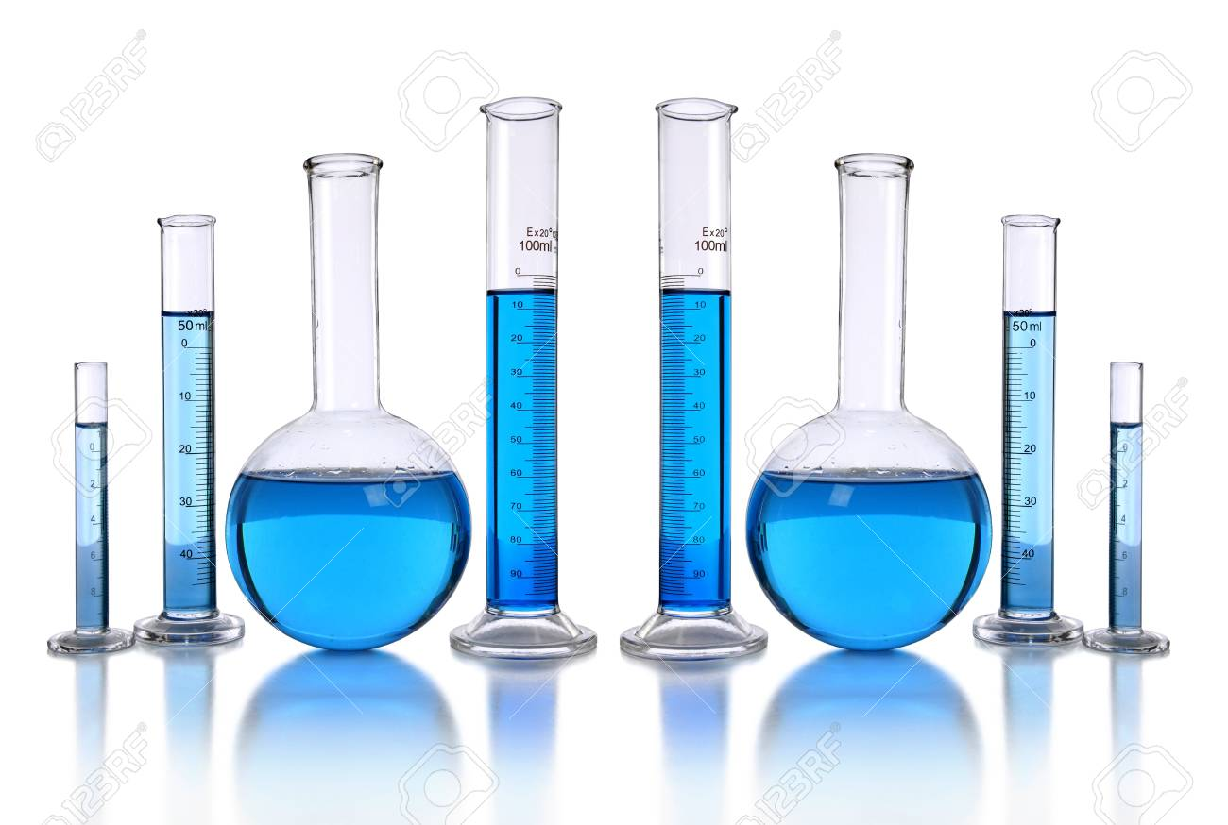
You have a large volume of blue liquid in an unmarked beaker.

1. Measure the volume of the blue liquid using the large beaker.
2. Measure the volume of the blue liquid with the small beaker.
3. Measure the volume of the blue liquid with the large measuring cylinder.
4. Measure the volume of the blue liquid with the small measuring cylinder.
5. Write down all the measurements in a table

(a. Which instrument is best for large amounts and which for small amounts? Give reasons.)

Measurement 2. Measuring specific amounts
1. You have a dropper pipette and a measuring cylinder
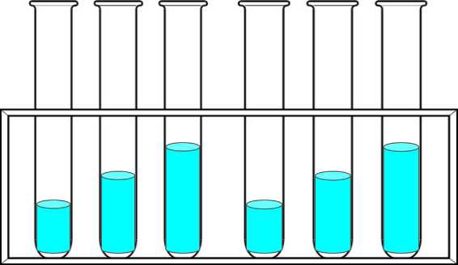
2. Using the dropper, measure out the following volumes and put them in the test tubes.
a) 2ml
b) 5ml
c) 7.5ml

3. Use the measuring cylinder to measure the same volumes and put them in the other test tubes
4. Compare the test tubes with the same amounts.

(b. Are the volumes measured exactly the same in both test tubes? If not, why not?
c) Which instrument is best for each volume? Give reasons.)

Measurement 3. Using a burette

1. Set up a burette
2. Fill the burette with water up to the top line, if you go over, let some water out until it gets to the line
3. Measure out 5ml of liquid from the burette as exactly as you can.

(c. What are the advantages / disadvantages of using a burette compared to beakers and measuring cylinders)

RESULTS

Experiment 1
 | Measuring instrument
Quantity measured | Large beaker | Small Beaker | Large Measuring cylinder | Small measuring cylinder
Volume of blue liquid

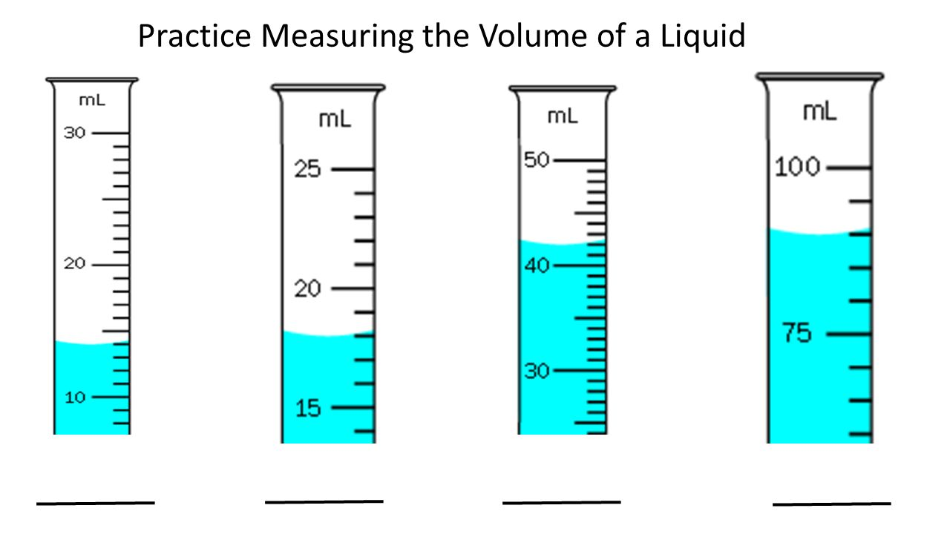

Conclusion
Answer the questions in green.
How can you decide which glassware to use?
What problems can happen if you use the wrong instruments?
What things can you do to improve your measurements?

