Session 3 | Temperature and Line graphs

Assessed criteria
LAB SKILLS:
- Take accurate measurements
- Drawing graphs of results
- Analyse data using graphs

Criteria C: Processing and Evaluating (Formative)

Criteria E: AIE

Research Question
How does insulation affect heat loss?
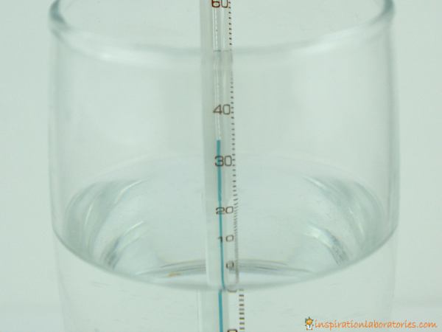

Objective
To obtain an accurate measurement of temperature over time.
To practice drawing line graphs and analysing data.

Materials
Beakers | Thermometers
Water | Stopwatches
Water heater | Cardboard
Sticky tape | Old newspaper
Background Information

Temperature is a measure of the amount of heat energy in a substance. We measure temperature in degrees Celsius ºC and can use a glass or electronic thermometer.
Heat energy moves in three main ways:
1. Conduction. When objects touch, heat moves from the hotter object to the colder.
2. Convection. When an object is in a fluid (liquid or a gas), the particles of the fluid can bump into the object and carry heat away.
3. Radiation. All objects give off (radiate) heat as infra-red radiation. Infra-red is a type of light our eyes cannot see but some animals can see infra-red and we can detect it with special cameras.

If we can stop or reduce any of these types of heat movement, then we should be able to stop objects from changing their temperature quickly.

Method

1. You will be given 2 beakers.
2. Insulate one of the beakers using the card and paper. Be sure to make a lid.
3. Leave the other beaker with no lid or insulation.
4. Heat up water in a water heater.
5. Put 150 mL of hot water into each beaker. (BE VERY CAREFUL)
6. Measure the temperature of the water in each beaker.
7. Write down the measurement in the row of Time 0
8. Measure the temperature every minute for 15 minutes.
9. Use the data to draw a line graph.

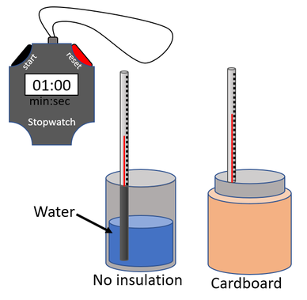

RESULTS

 | TEMPERATURE ºC
TIME | BEAKER WITH NO INSULATION | BEAKER WITH INSULATION
0
1
2
3
4
5
6
7
8
9
10
11
12
13
14
15
16

RESULTS

Plot both sets of data on the same line graph with different colours. Use graph paper.
Calculate the change in temperature of each beaker.

Conclusions

What happened in each beaker?

Which lost the most heat?

If we let the experiment run for another 5 minutes what temperatures would we get?

