Session 4 | Modelling the solar system

Assessed criteria
LAB SKILLS:
- Organise workspace in lab
- Follow instructions
- Group work and peer evaluation

Criteria A: Knowledge and understanding (Formative)
Criteria E: AIE

Research Question
How can we model the parts of the solar system?
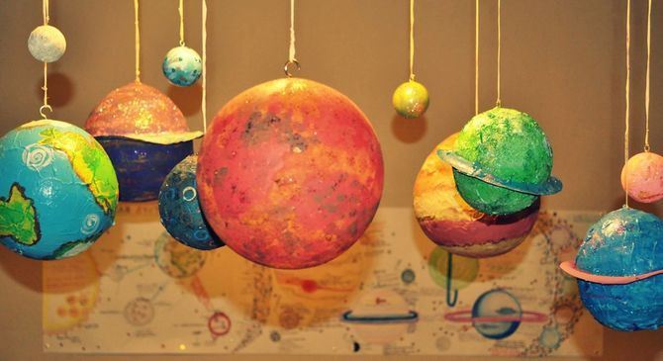

Background Information
The Solar System, in which we live, consists of the Sun as its central star, eight planets with their moons and several dwarf planets. Together with hundreds of thousands of asteroids and comets, these celestial bodies orbit the Sun.

The Earth is a very special planet among these celestial bodies. It is our home and the only world we know to have life on it. In order to understand its uniqueness, we need to compare the Earth to the other planets in the Solar System

We can categorise the planets of our Solar System into two types: the rocky planets, which are nearest to the Sun and have a solid surface, and the gas giants, which are farther from the Sun and are more massive and mainly composed of gas. Mercury, Venus, Earth and Mars appear in the former category, and Jupiter, Saturn, Uranus and Neptune make up the latter. Pluto, our formerly outermost planet, has been considered one of the dwarf planets since 2006. Between Mars and Jupiter is a the asteroid belt, which circles the Sun like a ring. It consists of thousands of smaller and larger bodies. The largest of these have their own names, just like the planets. One of them, Vesta, is so large that it is also considered a dwarf planet

Objective
To create models and informative posters that educate people about the characteristics of solar system objects.

Materials
Newspaper | Paints
PVA glue | Scissors
Water | Coloured Card
Tray/Bowls for mixing

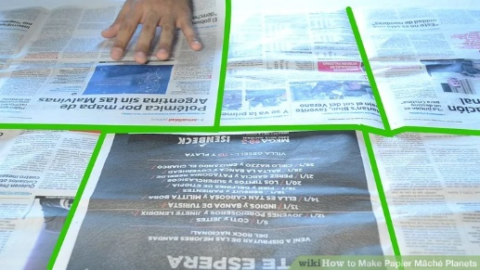
Method for Models
1. Lay down the newspaper to create a work area.

2. Mix the glue and water. You'll want a consistency that resembles the thickness of glue, but not so thick that it does not spread easily over your newspaper strips. If it is too thick add more water. If it is too watery, add some more glue.

3. Blow up a balloon until it is round
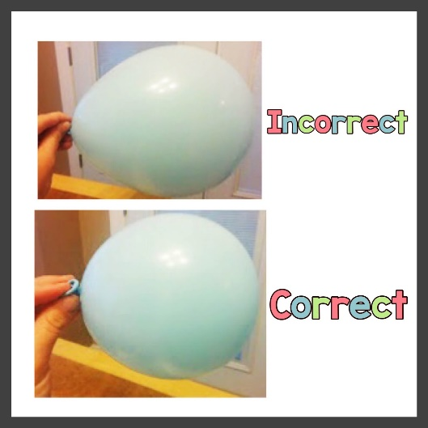

4. Tear the newspaper into long strips

5. Dip the paper strips into the glue mixture and then stick to the balloon, Until the balloon is completely covered. Try to do at least 3 layers.
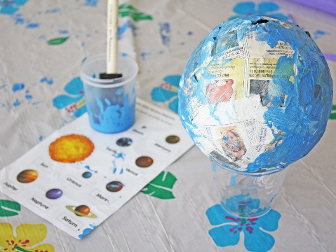
6. Leave the balls to dry

7. When they are dry, paint them based on your research on the planets.

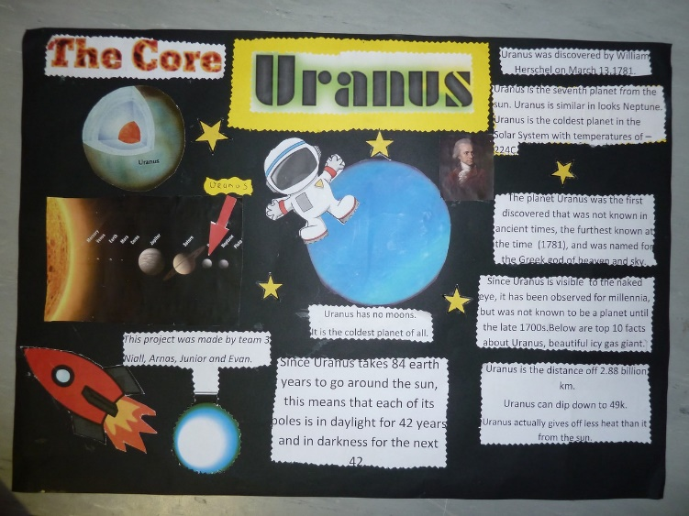
Posters

1. Each group will be assigned a solar system object.

2. Create a poster, informing people about the object.

3. Your poster should include:

- Pictures of the object.
- A comparison of scale with another object.
- Facts about the size, composition, gravity and orbit.
- The history or significance of the object.
- Some interesting trivia about the object.

Evaluation

Your work will be evaluated by others in the class. The mark will be shared by all the people in the group. The work will be evaluated on the following criteria:

- Presentation- Is the work neat, organised and well presented.
- Information – Is the information all present and is it accurate.
- Creativity – Is the poster interesting and has unique features
- Effort – Did you contribute to the group effort. This will be rated by your own group.

