Session 6: | MODELING THE WATER CYCLE

Assessed criteria
Criterion E: AIE

Research Question
“How does the Sun´s heat power the water cycle?”

Background Information

The water cycle describes how water evaporates from the surface of the earth, rises into the atmosphere, cools and condenses into rain or snow in clouds, and falls again to the surface as precipitation. The water falling on land collects in rivers and lakes, soil, and porous layers of rock, and much of it flows back into the oceans, where it will once more evaporate. The cycling of water in and out of the atmosphere is a significant aspect of the weather patterns on Earth (NASA.gov, 2017).

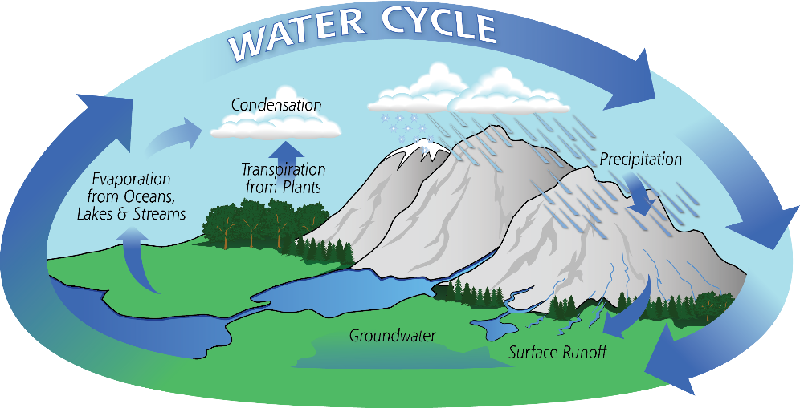

This can be modeled in the lab to demonstrate how the processes require the energy from the sun and the different temperatures in the atmosphere to work, as shown below:
SET UP 1
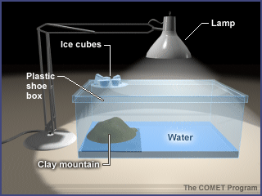
OR
SET UP 2
- Hypothesis (Complete this section – What will happen when you turn the lamp on? Why do you think this?)

Materials
SET UP 1
Plasticine | Plastic box | Petri dish | Lamp
Water | Crushed ice | Clear film

OR

SET UP 2
2 Stands | 2 Clamps | Bunsen burner | 500mL Beaker
Coloured Water | 2 Gauzes | Ice cubes | Tray

Method 1

- Using the plasticine, shape a mountain.
- Place the mountain on one side of the box with the sloped side facing the interior of the box where the "ocean" will be.
- Pour water into the "ocean" basin until about one-fourth of the mountain slope is covered.
- Replace the lid of the box or cover with the clear film.
- Place a petri dish on top of the shoe box over the mountain (as shown).
- Place crushed ice into the petri dish.
- Position the lamp over the ocean. Turn on the lamp. CAUTION: THE LAMP WILL GET HOT. DO NOT TOUCH THE BULB OR SHADE.
- Observe the container carefully and note any changes.

Method 2
- Set up the experiment like in the picture above
- Light the Bunsen burner with the help of your teacher
- Observe what happens during 15 minutes, discuss this within your team
- Answer the questions below

Results

Observations:

Conclusion (Complete this section – A conclusion is used to compare your results to what you stated in your hypothesis. Try to add scientific vocabulary and reasons for your observations from your references)
Questions:

1. Which part of the activity simulated evaporation?
2. Which part simulated condensation?
3. Which part simulated precipitation?
4. What is the energy source and what does it represent?
5. What elements of the water cycle are not represented?
6. How could we demonstrate transpiration in this activity?
7. Would condensation occur in the box/tray without the ice? Why or why not?
8. After observing this activity, explain why water is considered a renewable resource.
9. The system you observed/constructed is a model of the way the actual water cycle works. Why might scientists use a model like this in their research into the water cycle in the real world? Can you think of any reason that using such models might be a problem?

References

NASA.gov. (2017). Pmm.nasa.gov. Retrieved 30 November 2017, from https://pmm.nasa.gov/education/water-cycle

