Session 6: | COUNTING STOMAS ON PLANT LEAVES

Assessed criteria
Criterion C: Processing and Evaluating

Criterion E: AIE

Research Question
“Does the top or bottom of a leaf takin in most of the CO₂ a plant needs for photosynthesis?”

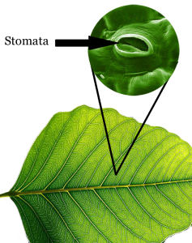
Background Information
Julia is explaining to her younger brother how plants make their own food and give out the oxygen we need to breathe. Her brother asks her how the plants breathe the gases in and out if they do not have lungs. She goes away and uses the internet and finds this website: http://www.saburchill.com/chapters/chap0025.html that shows this picture of the “holes” in leaves that allow gases in and out of the plant.

These holes are called stomata and are used to take in the carbon dioxide needed to perform photosynthesis, and let out the waste product, oxygen.

The problem for plants is that the holes can also let water vapour escape and plants also need water for photosynthesis! For this reason there are a different number of stomata on the top of the leaf compared to the bottom.

We can use two household products to investigate this: water cannot pass through greasy vaseline, and clear nail varnish can be used to take an imprint of surfaces that is transparent.

Objective
To estimate the amount of stomas on the bottom and top of a plant leaf and see which surface loses the most water.

Hypothesis (Complete this section – Hint: If there were an equal number of stomata on each side of the leaf, which side do you think would lose the most water? Why is the Sun important here?)
The side that will have the most stomata will be the top/bottom because ……………………………… ………………………………………………………………………………………………………………………………………………………………………………………………………………………………………………………………………………………………… .

Materials
Balance | Nail polish | 4 leaves (2 of them covered with varnish)
A glass slide | Sellotape | Scalpel
Vaseline | Tweezers | Microscope
Heat lamp
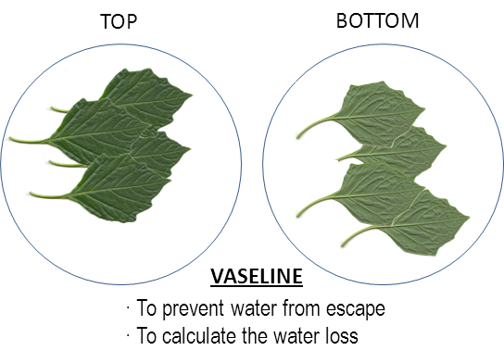
Method 1 – Water loss calculation
- Draw 2 circles on one sheet of blank paper. Write “Top” in one circle and “Bottom” in the other.
- To 1 leaf, apply Vaseline to ONLY the top side and place it in the circle that says “Top”.
- To the other leaf, apply Vaseline to ONLY the bottom side and place it in the circle that says “Bottom”. (1.Did you put the Vaseline evenly onto the surface of the leaf? Could some water still have escaped?)
- The teacher will collect all of the “Top” leaves, weigh them and put them in front of a heating lamp that will act like the Sun.
- The teacher will do the same for all of the “Bottom” leaves. Complete the first column of Table 1. (2. Are the “Top” leaves and “Bottom” leaves the same distance from the heat lamp?)
- At the end of the session the teacher will re-weigh the leaf so that you can complete the table.

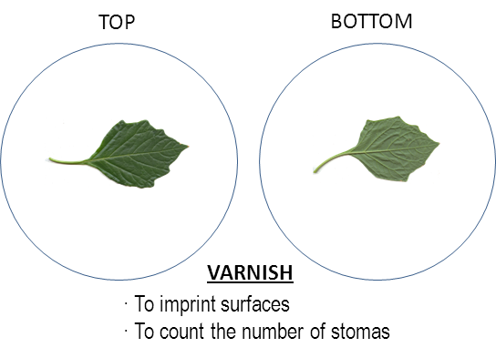
Method 2 – Number of stomata calculation
- Collect a leaf with nail varnish on the top side and carefully remove a section of varnish with the tweezers (approximately 1cm x 1cm).
- Carefully stick the varnish imprint onto a slide using a piece of sellotape.
- Observe your sample under the microscope.
- Count the stomata in one view and add them to the first row in Table 2.
- Move the view to a different part of your sample and perform a second count.
- Repeat and perform 5 counts in total.
- Repeat the procedure with the BOTTOM leaf.
- Calculate the average amount of stomata on each side and add this to Table 2. (3. Could one of your nail varnish samples be from part of the surface with less stomata than the rest? Or perhaps more?)
Results (Complete this section)
Table 1 – Table to show the mass of water lost through the top and bottom of a leaf
Side of leaf covered in Vaseline | Side stomata left uncovered | Initial mass (g) | Final mass (g) | Mass of water lost (g)
Top
Bottom

Table 2 – Table to show the number of stomata on the top and bottom of a leaf

Side of leaf covered in Varnish | 1st count | 2nd count | 3rd count | 4th count | 5th count | Average
Top
Bottom

Conclusion (Complete this section)

Table 1 shows that the top/bottom of the leaf lost the most water. This suggests that there must be more stomata on the top/bottom. Table 2 shows that, on average, there are more stomata on the top/bottom of the leaf. The results from my two experiments show same/different results.
Researching the internet, the side of the leaf that has more stomata is the top/bottom one (insert in-text reference here). This shows that my experiment was done accurately/inaccurately.

Evaluation (Complete this section – Look through the method and answer the blue questions below as you did in Session 1. Suggest an improvement for each one.)

References (Complete this section)

Saburchill.com,. (2014). The Open Door Web Site : Biology : How Plants Breathe : The Differences in the Exchange of Gases between Plant Respiration and Photosynthesis. Retrieved 2 July 2014, from http://www.saburchill.com/chapters/chap0025.html
Add your reference from the conclusion here.

