Session 6 | density of solids, liquids and gases

Assessed criteria
LAB SKILLS:
- Take accurate and precise measurements
- Process measurements and represent them in a graph
- State the precision of measuring equipment
- Analyse data using graphs
- Evaluate source of measurement errors.

Criteria C: Processing and Evaluating (Summative)

Criteria E: AIE

Research Question
‘How can we check if a ring is made of gold, and not just painted with gold leaf?’

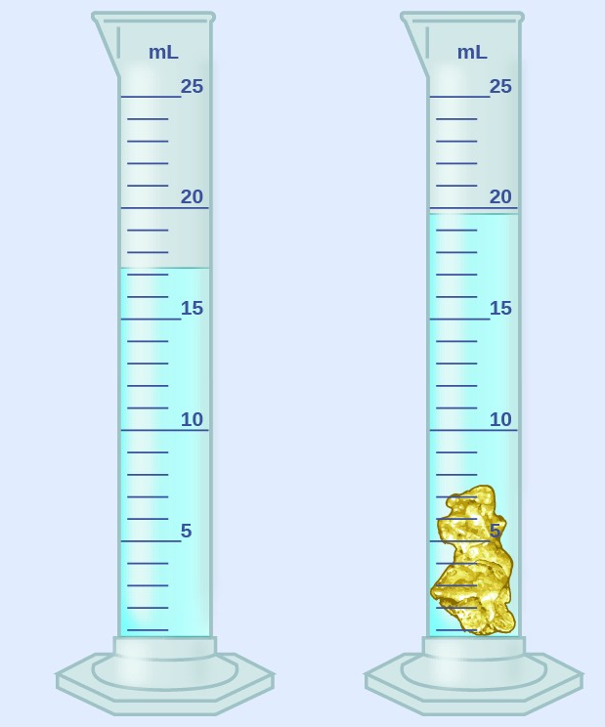

Objective
To obtain accurate measurements of mass and volume.
To practice reading off volumes.
To determine the composition of an unknown metal, by comparing its density of values for metals you have previously calculated
To practice drawing and reading graphs.

Materials
Electronic scale | Tap water
Measuring cylinder (10 mL) | Sunflower oil
Dropper | Regular objects (cubes)
Ruler | Irregular objects

Background Information

Density is a property of matter. Each object is made from some kind of material, and each material has a specific density, independent from the shape the object has and independent from how much matter is contained in that object. Therefore, density expresses the amount of matter per unit of volume of a substance. And every substance has its own density.
We can express density with the following mathematical formula:

density = mass / volume
d (kg/m³) = m (kg) / V (m³)

The SI unit (International System) for density is kg/m³, but we often express it in g/cm³.
Pure elements, like you find in the periodic table, all have a specific density. For example, pure gold (Au) is always 19.32 g/cm³ and pure plutonium (Pu) 18.9 g/cm³. Hydrogen gas (H₂), in a balloon for example, has a density around 0.0899 g/cm³.

Method
Irregular solids
- Fill a measuring cylinder with water to up to a volume of maximum 8 mL.
- Record the initial volume in Table 1, indicating the precision of the measuring cylinder used.
- Insert the object smoothly, making sure no water escapes.
- Read off and record (Table 1) the final volume of liquid with the solid in the measuring cylinder.
- Calculate the volume of the objects (Table 1).
- Remember that 1 mL = 1 cm³
- Measure the mass using the electronic balance, and record it in the Table (do not forget to state the precision of the electronic balance).
- Using the formula for density in the background, calculate the density of each object. Bring your answer to 2 decimals.

Regular solids
- Measure and record each side of the cube in cm; length, height and depth. And use the following formula to calculate the volume.  Volume of cube = length x height x depth | 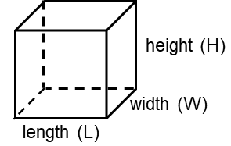
- Record the calculated volumes (cm³) in Table 2, indicating the precision of the ruler, and using 2 significant figures for volume.
- Measure the mass (g) using the electronic scale and record it in Table 1 (don´t forget to indicate the precision).
- Calculate the corresponding density. State the units and use 2 decimals.
- Take one of the cubes and measure its volume using the protocol for irregular solids. What volume do you obtain? Will the other cubes have the same or different volumes?

Liquids
- Place an empty measuring cylinder on the scale and tare it. Add some water (around 10 mL) and record its mass (Table 3).
- Record the corresponding volume (mind the precision) and calculate its density in Table 3.
- Repeat the protocol for sunflower oil.

Gases
1. Measure and record the mass of the empty balloon (Table 4).
2. Fill the balloon by blowing some air in it and seal the balloon.
3. Measure and record the mass of the balloon filled with air.
4. Calculate the mass of the air inside the balloon.
5. As we have no way of knowing the volume of our balloon, we will use the method of irregular object in order to determine its volume.
6. Use a large cylinder in which the balloon fits and record the volume of the balloon in table 4 (in cm³).
4. Calculate the density of the air inside your balloon.

RESULTS
Irregular solids

Table 1 - Complete
Object | Mass (unit) | Initial liquid vol. (unit) | Final liquid vol. (unit) | Vol. object (unit) | Density (unit)
Rock
Pink/green stone
Unknown metal

Regular solids

Table 2 - Complete
Object | Mass (unit) | Side of cube (unit) | Vol. object (unit) | Density (unit) | Real Density (unit)
Br cube (brass)
Tn cube (alloy)
Fe cube (iron)
Al cube (aluminium)
Pb cube (lead)
Cu cube (copper)
Zn cube (zinc)

Liquids

Table 3 - Complete
Liquid | Mass (unit) | Volume (unit) | Density (unit)
H₂O (water)
Oil

Gases

Table 4 - Complete
Gas | Mass of empty balloon (unit) | Mass of balloon with air(unit) | Mass of air (g) | Initial water volume (unit) | Final water volume (unit) | Volume of balloon with air (unit) | Density (unit)
Air

Conclusions

- Draw a graph of the metal cubes and their corresponding densities. Include the unknown metal in the graph.

- Determine the metal of the unknown.

I believe the unknown metal is , because …..

2) State the solid materials with the lowest and highest density.

3) Answer the following question. In general (for most materials), we can state:
a) d_{solids} < d_{liquids} < d_{gases}
b) d_{liquids} < d_{gases} < d_{solids}
c) d_{gases} < d_{liquids} < d_{solids}
d) d_{gases} < d_{solids} < d_{liquids}

4) Briefly explain how materials behave (arrange themselves) according to their densities

Evaluation

Go to the website for the Royal Soceity of Chemistry (RSC) http://www.rsc.org/periodic-table
and check the values of the metals you have calculated. Are they ‘correct’’?
You will only be able to find six of the metals, you need to check a minimum of three values to see if they are acceptable, be careful the units are different (they are in kg/m³) the conversion factor is to multiply by 1000 to go from g/cm³ into kg/m³

Are your values acceptable, how far ‘wrong’ are they? Why won’t you get the same value that the RSC gets? >Where are the possible errors? What can we do in the laboratory to get better (more accurate) results?

(hint: State at least one valid reason why the results may differ, referring to possible errors in your measurement and the precision of the equipment used to measure it.

Extra
- Search in literature the density for pure water and for pure gold (g/cm³). State your reference used (one example is given below).^{2,3}

References
- RSC Visual Elements Periodic Table. Royal Society of Chemistry (RSC). c.org,. (2014). Retrieved 2 July 2014. http://www.rsc.org/periodic-table.
- Ref. 2
- Ref. 3

