Session 7: | Water Content in Organic Matter
LAB SKILLS:
- Take accurate measurements
- Identify sources of error
- Carry out calculations

Assessed criteria
Criterion C: Processing and Evaluating
Criterion E: AIE

Research Question

Which organic material contains the greatest percentage of water?

Background Information

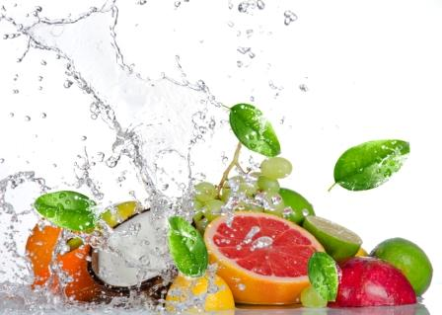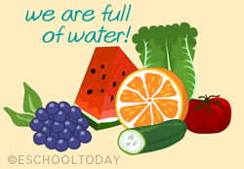
Water makes up an important percentage of living matter. On a general basis we can say that the average amount of water found in organic matter is about 75%, however, this quantity varies within different living matter. We can dehydrate animal and plants by eliminating the water, leaving behind “dry” matter. The weight difference, before and after dehydrating the organs, will give us the amount of water which each contained. (The amount of water contained can be calculated by subtracting the weight of the “dry” organs from the initial weight, before dehydration)

Objective
To determine the percentage of water of different foods.
Hypothesis (Complete this section – Hint: Do you think all living organisms have the same water content?
………………………………………………………………………………………………………………………………………………………………………………………………………………………………………………………………………………………………………………………………………………………………………………………………………………………………………………………
Materials

Electronic scale | Oven | Lettuce | Carrot | Orange
Petri dish | Tin foil | Tomato | Apple | Chick peas

Method (work in pairs)
- Cut 6 pieces of tin foil of about 10 x 10 cm and write your name or initials on one side.
- Place a piece of foil on the electronic scale (with your name facing down) and add around 5g of apple (don’t forget to tare the balance!). Write down the exact weight of your sample.
- Wrap up the apple making a little package with the foil.
- Do the same with the rest of the foods.
- Make sure you record all of the initial weights in table 1.
- Put all your packages in a Petri dish, with your name written on it, and place it in the stove at 60 ºC, where you will leave it for 2 days.
- After 2 days (48 h), take your samples from the stove and re-weigh all your packages. Record all the data in table 1.
- Determine the water content of each food:
Weight of fresh food: X
Weight of dried food: Y
Water lost during dehydration: X – Y = Z
% water contained in each food: Z / Y x 100

Results (Complete this section)
Table 1 – ________________________________________________________________________
Food
 | X  Fresh /g | Y  Dried /g | Z  Water lost /g | Percent Water / %

Calculations: Include a sample calculation of water lost during dehydration and water percentage. Make sure both calculations are of the same food sample.

Graph 1 : Draw a bar graph to represent the water percentage of each food.

(Insert your graph here – Make sure that it has title, and labelled axes with units)

Conclusions (Look at your results to explain what happened. Do your results agree with your hypothesis?)

Evaluation (Complete this section – Throughout this time you have been guided in order to complete this section. Let’s see what you can do after all that training!)

References (Complete this section)

