Session 1 | INTRODUCTION: SULFUR CLOCK REACTION

Assessed criteria

Criteria C: Processing and Evaluating (Formative)

Criteria E: AIE

Research Question

What happens in a chemical reaction when you increase or decrease the concentration of the reactants?

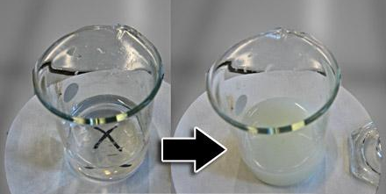

Background Information
A chemical reaction happens when reactants (the substances that you mix together) recombine to make new ones. Today we want you to think about how changing the amount of reactants will affect how fast reactions happen (reaction reate).

As you change the concentration of a solution, you are changing the amount of substance (or solute) of the solution. Therefore, increasing the concentration of a Hydrochloric acid solution (HCl) implies increasing the amount or quantity of HCl molecules in the same volume.

The reaction between Na₂S₂O₃ (sodium thiosulfate) and HCl (hydrochloric acid) starts as a clear solution that becomes cloudier, and finally turns opaque. This color change is due to the formation of sulfur during the reaction.

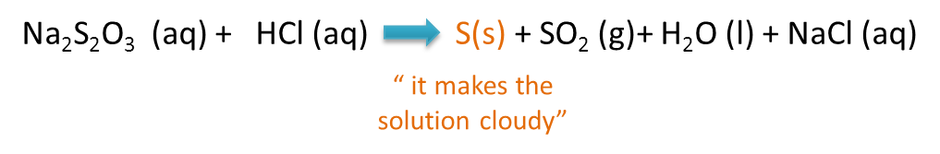

It is therefore easy to measure how fast or slow the raction takes place by placing the flask with the reagents over a white piece of paper marked with a ‘dark X’. As the reaction takes place, and the solution becomes cloudier and cloudier, we will eventually not be able to see the cross. Once we no longer see the cross, we can say the reaction has finished.

According to the Collision Theory, in order for a reaction to take place the molecules of the reactants must hit each other (collide). Therefore, increasing the number of collisions will also increase the reaction rate.

*VARIABLES
INDEPENDENT - the quantity of HCl (hydrochloric acid) added to the experiment - measured in mL
DEPENDENT - the time taken for the reaction to happen, the time for the cross to ‘disappear’ measured in seconds with a stopwatch
CONTROLLED - the things we have to keep the same.(you need to add some things here, what things do we need to keep the same?)

Objective
To determine how the concentration of one of the reactants (HCl) affects the rate of the reaction between Na₂S₂O₃ (sodium thiosulfate) and HCl (hydrochloric acid).

Hypothesis (Complete this section)
The rate of reaction will increase/decrease when the concentration of HCl is increased. I think this because in the background information section it says that ……………………………………………… …………………………………………………………………………………………………………………………………………………………………………………………………………………………………………………………………..…………………………………………………………………………………………………………………………………………….… .

Materials
100 mL beaker with a 0.25M sodium thiosulfate solution | A ruler
100 mL beaker with a 0.10M hydrochloric acid (HCl) solution | A stopwatch
100 mL Erlenmeyer flask | Goggles
A 15x15 cm piece of white paper | A marker
Two 50 mL measuring cylinders

Method
- SAFETY: You must wear your safety goggles until the end of the experiment.
- Make sure you have all the needed material before you start.
- Draw a clearly visible cross in the middle of white paper and place the Erlenmeyer flask on top.
- Using the measuring cylinder, measure 25 mL of Na₂S₂O₃ and pour it in the Erlenmeyer flask.
- USING A DIFFERENT MEASURING CYLINDER measure 5 ml of HCl.
- IMPORTANT! The reaction will start as soon as the HCl comes in contact with the thiosulfate, SO add the acid to Erlenmeyer flask and inmediately start the stopwatch!!
- Look from above the flask, and stop the watch when you cannot longer see the cross. Record this result in your notebook
- HAZOUR: YOU MUST DISCARD THE SOLUTIONS SAFELY. USE THE PROVIDED CONTAINERS AND DO NOT USE THE SINKS.
- Repeat steps 4 - 7 with 10mL, 15mL, 20mL and 25mL HCl
- Tidy up following the Teacher’s instructions.

