Science year 7
2nd Term Formative Activity

Name and surname
Date: Results. MYP:_________.

Task | Design an Investigation: Modeling the Water Cycle

Criterion B: Inquiring and designing

Level 7 – 8
The student is able to:
i. describe a problem or question to be tested by a scientific investigation
ii. formulate and explain a testable hypothesis using correct scientific reasoning
iii. describe how to manipulate the variables, and explain how sufficient, relevant data will be collected
iv. design a logical, complete and safe method in which he or she selects appropriate materials and equipment.

Task: Design an experiment that investigates the how the rate of a process in the water cycle (dependent variable) is affected by one factor that you choose (independent variable).

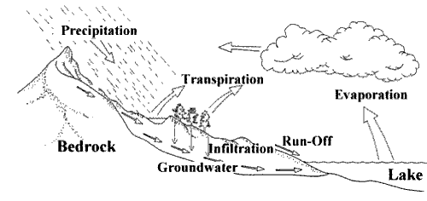

Look at the water cycle and write down all the processes involved (evaporation, condensation etc). Choose one and brainstorm what factors might change how fast it happens. In science, we call how fast something happens the rate.
Choose one thing to investigate. What other things should you keep the same to make it a fair test? Can you describe exactly how you will measure the rate?
Plan the investigation by completing each section of the format below. You will need to use http://www.sciencesfp.com/how-to-write-a-lab-report.html to help complete each section and check the example investigation on the same page to help.

Research Question
How does _____IV_____ affect the rate of _____DV___?
Background Information

Hypothesis

I think that as the ______IV_____ increases, the rate of ____DV________ will increase/decrease. I think this because…..

Variables

Independent (what you are changing and how you will change it), 3 different amounts, 3 times each.

Dependent (what you are measuring and how you are measuring it with the corresponding units)

Controlled (include all the relevant or important controlled variables)

Materials

Method (Write down everything you need to perform the experiment)

References

APA style
Use http://www.citethisforme.com/
You only need to copy and paste the part after “bibliography:”
Remember that Wikipedia or yahoo answers IS NOT a reference, it is a starting point to find other acceptable references.

Use the above mark scheme to make sure you have completed the task to MYP levels 7 – 8 by having a clear research question, well-researched background information that is used to support your hypothesis, correctly named equipment and a clear method in a numbered list that will generate data to write in a table and answer your research question.

