Science year 7
2nd Term Sumative Activity

Name and surname
Date: Results. MYP:_________.

Task | Design an Investigation: Studying photosynthesis

Criterion B: Inquiring and designing

Level 7 – 8
The student is able to:
i. describe a problem or question to be tested by a scientific investigation
ii. formulate and explain a testable hypothesis using correct scientific reasoning
iii. describe how to manipulate the variables, and explain how sufficient, relevant data will be collected
iv. design a logical, complete and safe method in which he or she selects appropriate materials and equipment.

Task: Design an experiment that investigates how a factor (dependent variable) affects the rate of photosynthesis (independent variable).
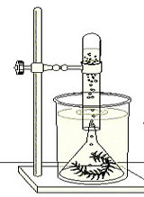
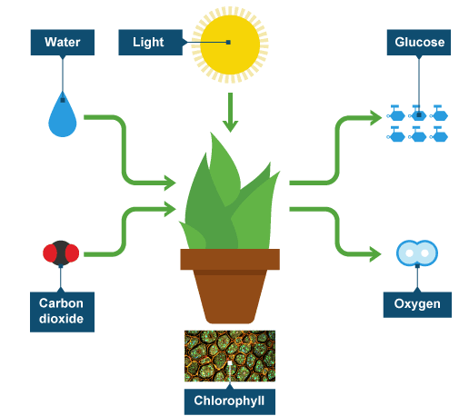

(BBC, 2019) (Shannan, 2019)

Plants carry out autotroph nutrition and that is why they are called autotrophs. There are several ways you can use to monitor how fast photosynthesis happens, like the one in the image on the right. The speed or, as scientists say, the rate of photosynthesis changes depending on several factors (light, temperature, water, carbon dioxide). You have to choose one of these factors and design an investigation based on the set up in the image to see how it affects the rate of photosynthesis.

Plan the investigation by completing each section of the format below. You will need to use http://www.sciencesfp.com/how-to-write-a-lab-report.html to help complete each section and check the example investigation on the same page to help.

Research Question
How does _____IV_____ affect the rate of _____DV___?

Background Information
What do plants do photosynthesis for? What’s the photosynthesis reaction? What can affect the rate of photosynthesis? Which of these factors have you chosen? How are you going to investigate how that factor affects the rate of photosynthesis?

Note: remember to include your references below in the section “References”.

Hypothesis

I think that as the ______IV_____ increases, the rate of ____DV________ will increase/decrease.

I think this because…..

Variables

Independent (what you are changing and how you will change it), 3 different amounts, 3 times each.

Choose one from: amount of light, temperature, volume of water or concentration of carbon dioxide.

Dependent (what you are measuring and how you are measuring it with the corresponding units).

Tip: base your investigation on the use of a water plant.

Controlled (include all the relevant or important controlled variables)

Materials (List all materials and their amounts)

Method (Write down everything you need to perform the experiment)

References

APA style
Use http://www.citethisforme.com/
You only need to copy and paste the part after “bibliography:”
Remember that Wikipedia or yahoo answers IS NOT a reference, it is a starting point to find other acceptable references.

BBC. (2019). BBC - Intermediate 2 Bitesize Biology - Photosynthesis : Revision, Page 3. Retrieved from http://www.bbc.co.uk/bitesize/intermediate2/biology/living_cells/photosynthesis/revision/3/

Shannan, M. (2019). Rate of Photosynthesis. Retrieved from https://www.biologycorner.com/worksheets/photosynthesis_rate.html

Use the above mark scheme to make sure you have completed the task to MYP levels 7 – 8 by having a clear research question, well-researched background information that is used to support your hypothesis, correctly named equipment and a clear method in a numbered list that will generate data to write in a table and answer your research question.

