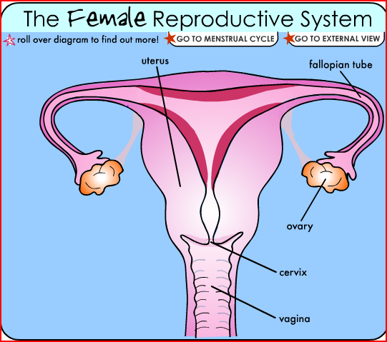
FEMALE REPRODUCTIVE

- What is reproduction?
- Give a definition for…
Gamete
Sperm
Egg or ovum

3. Complete following table
Organ | Function
Ovary
Fallopian tube
Uterus
Cervix
Labia
vagina

4. What is ovulation?
5. Name the female sex hormone produced
6. What is fertilisation?
7. Which part of female reproductive system does fertilisation normally happen?
8. What is implantation?

