Session 10: | The structure of DNA and rna
Skills developed in this session:
- Making models to understand complex structures

Assessed criteria
Criterion E: AIE

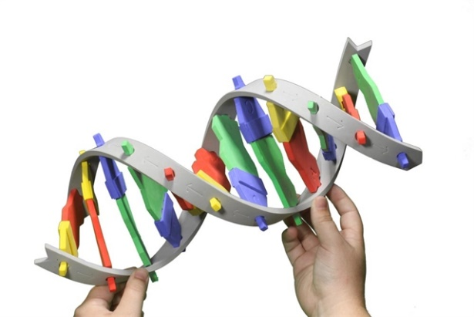
Objective
To understand the structure of DNA and RNA and the process of Transcription and translation by making a model.

Materials
- Piper cleaners of different colours
- Scissors
- Tape
- A laptop

Method
Working in pairs
After reading the notes here below, watch the following clip on how to make a DNA double helix with Pipe cleaners: LINK
IMPORTANT NOTES
- In the video they use always two the same bases on one side and two on the other side. Try to have all four bases on each side, and randomly ordered.
- Cut four bases from each pipe cleaner, not 5 as in the video, so they become a bit longer.
- Instead of using tape to fix the bases to each other, try to fold them around each other.
- Make sure you have 9 base pairs in total (so 9 complementary bases on each of the strands)
- Let the quality of your model be checked by your teacher
- Take a picture of your model and add it here below:

- Give each base a specific colour, write them down here:
A: (colour)
T: (colour)
G: (colour)
C: (colour)
- Watch the following video to understand how the message of DNA (order of the bases) becomes a protein: LINK
- Now choose one of the two strands of your model to be the ‘leading strand’. From this strand you make, with the pipe cleaners, a single RNA strand. Use a different colour if possible for your Uracil. Add the picture here below.

- Write down the bases of your mRNA:

- Use the diagram below to figure out which amino acids will be made in the translation of your mRNA strand:
Amino acid 1:
Amino acid 2:
Amino acid 3:
