|  |  |
| --- | --- |
| **Session 11 :** | **MITOTIC INDEX** |

## 

## Assessed criteria

Criteria C: Processing and Evaluating (*Formative*)

Criteria E: AIE

**Research Question**

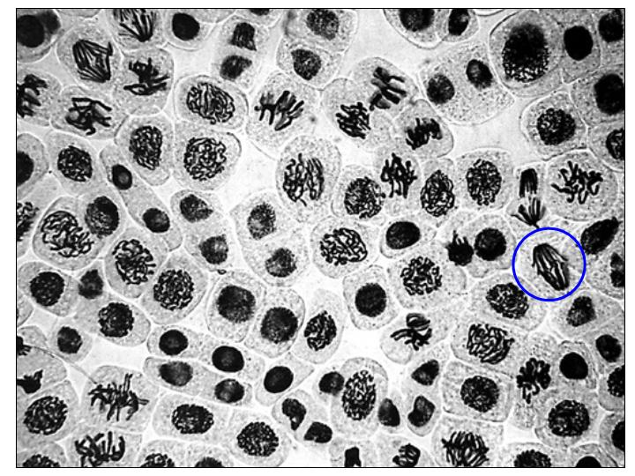“Which is the mitotic index (MI) on an onion root tip?”

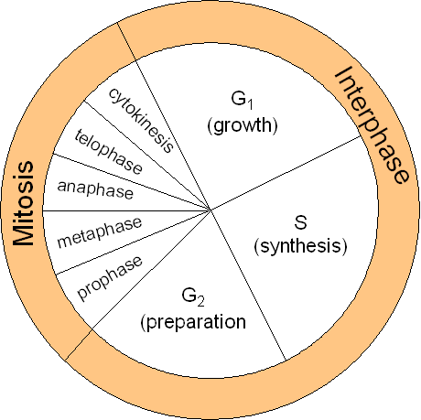

**Background Information**

The zone of cell division on an onion root tip is a great place to observe mitotic cell divisions. Through the observation and comparison of different regions of the root tip, the duration of mitotic stages and mitotic indexes may be determined for the cells of the root tip.

The mitotic index (MI) is the percentage of cells undergoing mitosis. It is determined by counting the total number of nuclei observable, and then recording the number of cells undergoing each stage of mitosis.

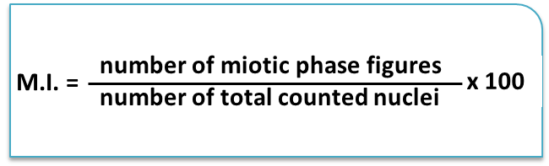

The duration of mitotic stages can then be determined using a formula based on the assumption that for onion roots cells, the beginning of interphase to the end of telophase lasts approximately 24 hours.

**Objective**

To observe and describe plant cells in the different phases of the cell cycle: interphase, and mitosis (prophase, metaphase, anaphase and telophase).

**Materials**

|  |  |  |
| --- | --- | --- |
| Onion | Slides | Gloves |
| Scissors | Cover glass | Bunsen burner |
| Watch glass | Pasteur pipette | Safety goggles |
| Orceine A | Filter paper | Wooden pincers |
| Tissue paper | Microscope | Immersion oil |
| Orcein B (Orcein acetate) | Scalpel or tweezers |  |

**Method**

1. Cut a small part of a growing root tip (no more than 1-2 mm).
2. Place on a watch glass.
3. Add a few drops of Orceine A, pass the watch glass briefly through the high part of the flame the Bunsen Burner for a few seconds till you are able to see steam rising.
4. Inmediatelly, place the root tips on a slide, add two drops of orceine B, and place a cover slip on top.
5. Cover the slide with a small piece of paper and push down gently, but firmly, with a fingertip to obtain a homogeneous layer of cells.
6. Look at the sample under the microscope, first with the lower magnifications and then with the 400x magnification.
7. Estimate the total number of nuclei you observe and the number of nuclei which undergo any of the mitotic phases. Organise this in a table.
8. Calculate the mitotic index with the following formula:

M.I. = number of mitotic phase figures / number of total counted nuclei x 100

**Results** (*Complete this section*)

Insert a suitable table here and perform your calculations underneath. Choose an appropriate style of graph to represent your results.

**Conclusion** (*Complete this section*)

What do your results show? Refer to the data you obtained.

**Evaluation** (*Complete this section*)

What problems can you find with the experimental method here? What suggestions can you make to improve the method?

**References** (*Complete this section*)

**IF NO RESULTS ARE OBTAINED USE THE FOLLOWING IMAGE INSTEAD**

