Session 8: | KMnO₄ serial dilutions:  Moles and concentration

Assessed criteria
Criteria C: Processing and Evaluating

Criteria E: AIE

Research Question
“How do we know the concentration of diluted solutions?”

Background Information
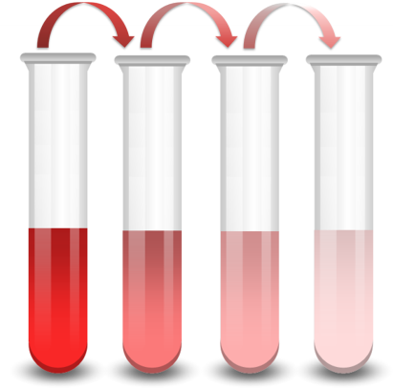
In science, concentration is a measure of the number of particles (solute) in a given volume. If one room has 100 people in it, and a room of equal size has 50 people, one can say that the concentration of people in one room is twice that of the other.
In chemistry, we are interested in the concentration of solutions and, related to that, it is important to know the meaning of the following concepts:

SOLUTION: a homogeneous mixture of a solute dissolved in a solvent.

SOLUTE: can be thought of as the “particulate” part of the solution. It is generally the smaller quantity and is “enveloped” by the solvent. It may be solid, liquid, or gaseous.

SOLVENT: generally the greater quantity in the solution. It is the “suspending” or “carrying” medium, and is generally liquid, although it may be gaseous. For now, we will deal only with liquid solvents. Therefore, unless stated otherwise, the solvent is understood to be water.

If we know the mass of the initial solute, and it is dissolved by adding solvent to make a solution of an exact volume, we can calculate the concentration of the solution. We will produce a series of solutions from a sample of a coloured liquid by making dilutions:

DILUTION: is the process of lowering the concentration of a solution by the addition of more solvent (in this case, water). Concentration is the opposite of this process.

Objective
To produce a series of solutions and calculate their concentrations.

Hypothesis (Complete this section – Hint: Try a picture what is happening to the molecules in the solution)
I think that as we add more distilled water to each sample, the colour will ………………………………
……………………………………………………………………….………………………………………………………………….......
This is because ………………………………………………………………………………………………………………..………… ……………………………………………………………………….………………………………………………………………….......

Materials
Potassium permanganate | Plastic pipettes
Distilled water | Gloves
5 and 25 mL glass pipettes | Goggles
100 mL volumetric flasks (4 per group) | Marker
100 mL Beaker

Safety (Complete this section)
This lab session has 3 hazards that we must consider to be able to carry out the experiment safely. Complete the table below to show you can work safely in the lab.

Chemical/equipment | Hazard symbol | What do you think hazard symbol means? | What will you do to reduce the risk of injury?
KMnO₄
KMnO₄
KMnO₄

Method _
You have a solution that has been prepared by weighing 0.40 g of potassium permanganate and water has been added until make an exact volume of 1L.

- Take 25 mL of this solution out of the flask using a glass pipette, and transfer into a 100 mL flask.
- Make an exact solution of 100 mL with distilled water, in flask 1.
- Invert the flask to ensure you have produced a homogenous mixture.
- Take 5 mL of the solution in flask 1 (using a glass pipette) and transfer to the second flask.
- Make an exact solution of 100 mL with distilled water, in flask 2.
- Invert the flask to ensure you have produced a homogenous mixture.
- Take 5 mL of the solution in flask 2 (using a glass pipette).
- Transfer to the flask 3.
- Make an exact solution of 100 mL with distilled water, in flask 3.
- Invert the flask to ensure you have produced a homogenous mixture.
- Take 25 mL of the solution in flask 3 (using a glass pipette).
- Transfer to the final flask 4.
- Make an exact solution of 100 mL with distilled water, in flask 4.
- Invert the flask to ensure you have produced a homogenous mixture.

Results (Complete this section)
Molecular mass of potassium permanganate KMnO₄= ……………………………..

Table 1 – Table to show …
 | Solution 1 | Solution 2 | Solution 3 | Solution 4
Nº moles
Concentration
(……)

Calculations

Conclusion (Complete this section- In your conclusion, apart from relating your hypothesis with your results, make sure you answer the following questions:
1. Did the concentration change when you removed some solution from the flask? (E.g. you now have 95 mL in flask 1. Does it have a different concentration compared to when there was 100 mL in there? ) Explain your answer.
2. Why do you think the colour has gone paler? Explain with reference to the molecules in the solution.)

Evaluation (Complete this section – Look through the method and answer these questions:
1. How accurate do you think you made your solutions? Could there be any problems with the equipment you used? (Be specific). Is there anything you could do to make the method more accurate.)

References (Complete this section)

Add your reference from the conclusion here.

