Session 10: | HEART DISSECTION

Assessed criteria
Criterion E: AIE

Research Question
“What does a real heart look like and how can I recognize its parts?”

Background Information
The heart dissection is probably one of the most difficult dissections you will do. Part of the reason it is so difficult to learn is that the heart is not perfectly symmetrical, but it is so close that it becomes difficult to decide which side you are looking at (dorsal, ventral, left or right). Finding the vessels is directly related to being able to orient the heart correctly and figuring out which side you are looking at.

The heart is also difficult because the fatty tissue that surrounds the heart can obscure the openings to the vessels. This means that you really must experience the heart with your hands and feel your way to find the openings. Many people will be squeamish about this, and because the heart is slippery, it is easy to drop. Don't be shy with the heart, use your fingers to feel your way through the dissection.
LINK TO DO A DIGITAL DISECTION

Objective
To learn how to dissect a heart and understand its anatomy.

Materials
- Scalpel (WARNING!)
- 2 Tweezers
- Tray with filterpaper
- Metal rod
- Needles
- White tape
- Pen
- Mobile phone
Instructions

1. Step One: Orientation
Make sure the heart is facing you from its front, with the right ventricle on your left and the left ventricle on your right.

ADD HERE A PICTURE OF THIS STEP

Step 2: Locate the main vessels
Use the metal rod to locate the main blood vessels connected to the heart. Move it carefully down the main arteries and veins and figure out where it ends up. According to that location you should be able to discover which is which blood vessel.
To which part of the heart is the aorta connected?........................................................................
To which part of the heart are the pulmonary arteries connected?...............................................
To which part of the heart is the vena cava connected?................................................................
To which part of the heart are the pulmonary veins connected?...................................................

ADD HERE A PICTURE OF THIS STEP

Step 3: Make the Incisions
Carefully cut open the heart. Make sure you always cut away from yourself, never towards your fingers! Make sure both chambers and atria are visible. Try to make sure you get a view similar to the illustration here.
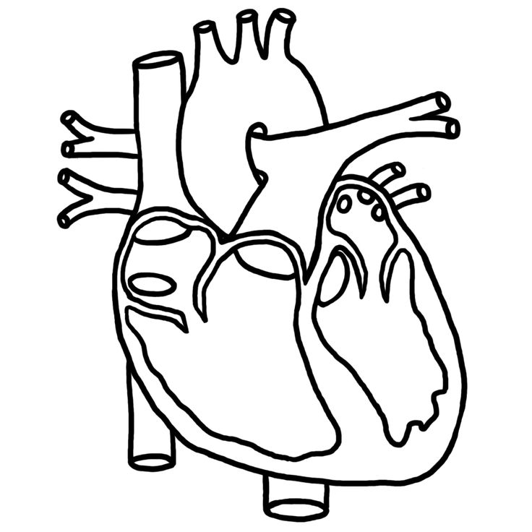

ADD HERE SOME PICTURES OF THIS STEP

Step 4: Label all the parts you recognize
With the needles and the white tape make little flags to label:
- Left ventricle
- Right ventricle
- Right atrium
- Left atrium
- Pulmonary artery
- Pulmonary vein
- Vena cava
- Aorta
- Any other structure you recognize

ADD HERE SOME PICTURES OF THIS STEP

Upload this document to your NSD in Drive!

