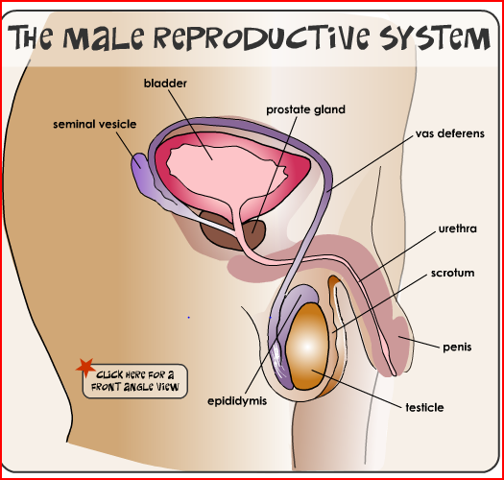
MALE REPRODUCTIVE SYSTEM

1. What is the function of the male reproductive system?
2. What is another name for sex cells?
3. What is male gamete called?
4. Complete the following table

Organ | Function
Testicles
Penis
Scrotum
Vas deferens
Seminal vesicle
Epididymis
Seminal vesicle
Prostate gland
Bladder
Urethra

5. Name the hormone produced by testes.
6. What is the scrotum and how does it maintain its temperature.
7. What is ejaculation?
8. How does fertilisation or conception happen?

