DEPARTAMENTO DE  CIENCIAS NATURALES | Exam  10º Physics and Chemistry
Nombre
Date ____________________ Mark _____/ D_____. E_____. F_____.

Level 1-2
- State the formulas for molarity, molality and molar fraction.

- Calculate which is the fastest of these speeds: 100 km/h; 40 m/s; 0.02 km/s

- Draw a simple parallel circuit that contains a battery, 2 resistors and 2 bulbs. (They do not need to be in a particular order)

Level 3-4
- Formulate these compounds: ammonium chloride, gold(I) oxide, nitrous acid, strontium hypobromite, methane, Ni(OH)₃, HClO, B₂H₆, Sc₂S₃, K₂Cr₂O₇.

- Methane reacts with oxygen gas to form carbon dioxide and water. Write a balanced equation and calculate how many mole of water are produced if we use 2 moles of methane and 4 moles of water.

- Explain how Bohr´s model of the atom explains atomic emission spectra like the one below.

Level 5-6
- A body moves from rest with a constant acceleration of 8 m/s². Calculate the velocity after 5 s and the distance travelled in the first 5 s.

- A sample of He(g) occupies 15.0 L with a pressure of 856 mmHg when the temperature is 52 ºC. How many grams of He(g) does the sample contain?
Data: atomic mass He=4 g/mol; 1 atm = 760 mmHg; R = 0.082 atm·L/K·mol

- Calculate the volume of a 10000 tonne ship that is submerged if the density of seawater is 1030 kg/m³.

Level 7-8
- How many grams of acetic acid should we dissolve in 250 mL of water in order to change its boiling point up to 101.3 °C?
Data: molecular mass acetic acid = 60 g/mol; density of water = 1g/ml.

- An electrolytic cell was set up with an unknown manganese ion solution. It was run for 10 minutes at a current of 4 A and produced a mass of 0.684 g of manganese metal. Calculate the oxidation state of the manganese in solution.
Data: Atomic mass=55; F=96500 C/mol, Common oxidation states of manganese = +2,+6,+7

- The Hindenburg was a large hydrogen filled balloon that caught fire when it came close to the metal landing tower that it was supposed to be attached to. One theory is that static electricity caused the fire. Explain how.
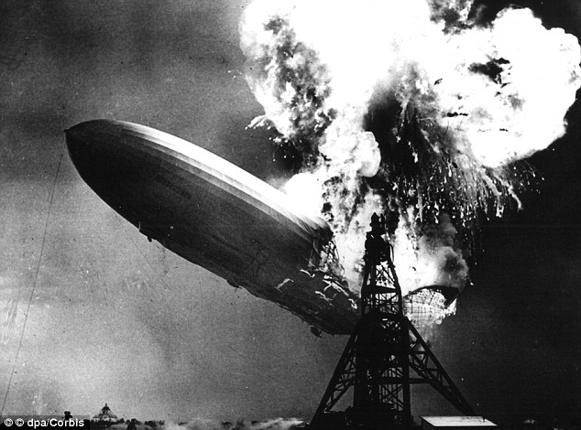

- Aluminium hydroxide
- Sodium hypoiodite
- Hydrobromic acid
- Iron(II) chromate
- Borane
- NaNO₂

- CH₄
- Cu₂SO₄
- HCN
- Ag₂CO₃
- Li₂O₂
- NaBrO₂
- KMnO₄
- H₃PO₄
- NH₃

- Diborane
- Hydrosulfuric acid
- Sulfurous acid
- Sulfuric acid
- Hydrogen sulfide

- H₂O₂
- Mg₃N₂
- LiClO₂
- HBrO₂
- H₂S
- K₂Cr₂O₇

- Osmium(VIII) oxide
- Aluminium periodate
- Sulfuric acid
- Caesium sulfide
- Xenon tetrafluoride

- H₃BO₃
- LiMnO₄
- H₂O₂
- SrO
- Au(OH)₃

