Superbabies

Use your knowledge of genes and inheritance to determine the probability of any offspring of these superheroes having their powers

h = allele for the power to heal f = allele ability to fly
m = allele for mind reading powers s = allele for super strength
o = allele for the ability to control the whether
w = allele for the ability to climb up walls l =allele for laser eyes

Remember: Mutated genes are recessive

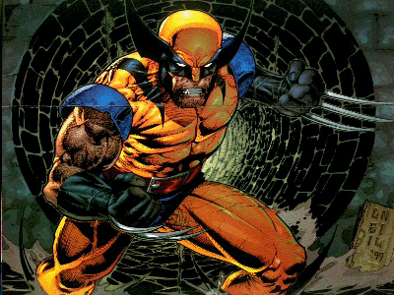
Wolverine
hh
MM
ss
Ff
Jean Grey
Hh
ff
mm
Ss

Rogue’s Genotypes
ff
Ss
LL

Superman
ff
ss
ll

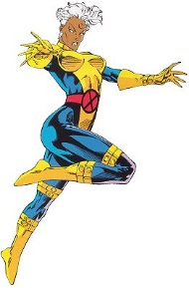

Cyclops
FF
ll
OO

Storm
ff
LL
oo

Spiderman
FF
ss
Ll
rr
ww

Supergirl
Ff
ss
ll
Rr
WW
