The menstrual cycle

1 The diagram shows how the thickness of the lining of the uterus changes. Write these labels in word boxes above the diagram.

The lining gets thicker An egg is released
The lining breaks down The lining stays thick

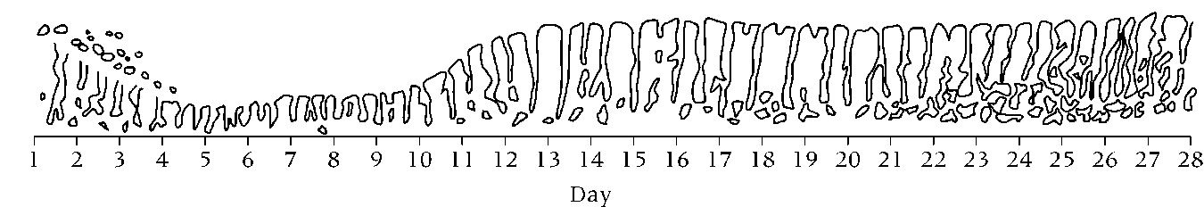

2 Now complete these sentences using the words in the box.

blood fertilised menstruation ovaries ovulation period vagina

a Egg cells are released from the ___________________ . The time when they are

released is called ___________________. If the egg cell meets a sperm cell it

will be ___________________. If it does not, it will die.

b The time when the uterus lining breaks apart is called ___________________ . Another

name for this is ‘having a ___________________.’ During this time the uterus lining

and a little ___________________ passes out of the ___________________.

