Session 2 | Measuaring general properties of matter to determine density

Assessed criteria
Criterion C: Processing and evaluating
Criterion E: AIE

Objectives
To learn more about density, an intensive characteristic of matter.

Background
Everything we see is made of matter. Mass and volume are two extensive properties of matter that are needed to determine the density of a body. Density on the other hand is an intensive property of matter.

We can then use the formula shown below to calculate the density:

Density = mass / volume

Why do objects that are the same size sometimes have different weights? The answer is to do with their density. An objects density is determined by comparing its mass to its volume.

If you compare a rock and a cork that are the same size (they have equal volume), which is heavier? The rock is heavier because it has more mass. The rock is denser than the cork then, because it has more mass in the same volume – this is due to the atomic structure of the elements, molecules and compounds that make it up.

But, how can we measure the volume of an object?
The amount of space an object takes up is called its volume. The volume of regular shaped solid objects can be easily calculated using mathematics. However, how can we measure the volume of an object with an irregular shape? Well, this problem was solved many years ago by a man named Archimedes who lived in Greece.
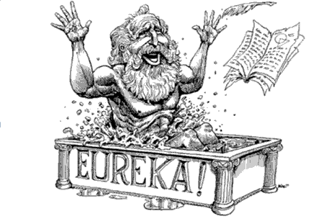
Eureka!
This exclamation was most famously said by the ancient Greek scholar Archimedes; he shouted "Eureka!" when he stepped into a bath and noticed that the water level rose — he suddenly understood that the volume of water displaced must be equal to the volume of the part of his body he had submerged.
This meant that the volume of irregular objects could be measured with precision, a previously very difficult problem. Apparently, he wanted to tell everybody his realisation so much, that he leapt out of his bathtub and ran through the streets of Syracuse naked!

Here is a diagram to demonstrate this principle.
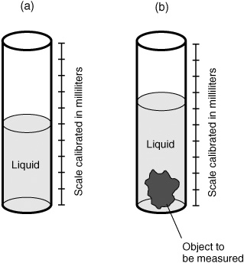
- In measuring cylinder (a) the initial volume of a liquid is measured.
- The object to be investigated is then placed in the measuring cylinder and the water level rises due to the object taking up space (volume) inside the cylinder.
- The final volume is measured as shown in (b) and the volume of the object can then be calculated using the following equation:
$$Final volume of liquid-Initial volume of liquid = Volume of the solid$$

Materials
- 3 cubes of known material
- 2 irregular objects
- 2 regular objects
- Measuring cylinder
- Electronic scale

Procedure
- Measure the mass of your solids on the electronic scales (remember to use the tare button before putting your solid on the tray of the scales).
- Use a measuring cylinder to determine the volume of the different objects. Record the initial and final volumes for each object in a table.
- Calculate the difference between the initial and the final volume to determine the volume of each object.
- Record all the data in a table.
- Calculate the densities of the all objects: include your calculations.
- Present the processed data in a table and represented it in a graph
- Compare the measured densities of the cubes of known materials to their actual density. Are your results accurate?

Results
Fill in the data as you carry out the experiment.
Table 1. __________________________________________________
Object | Mass (units) | Initial Volume (units) | Final Volume (units) | Volume of object (units)

Calculations: (show a sample calculation for the final volume on one of your objects)

Results

Conclusions and Evaluation

