Lab practice 5: Properties of Chocolate
Assessed criteria: C and AIE
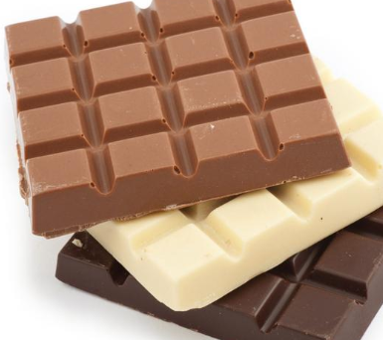
Objectives
- To practice and become more confident on important laboratory skills such as the use of the electronic scale, thermomethers and accurate measurements.
- To study intensive and extensive properties of chocolate.
- To develop self-management skills such as organization.

Materials

- Water
- Dark, white, and milk chocolate
- Beaker
- Thermometer
- Electronic scales
- Measuring cylinder
- Wash bottles with water
- Stopwatch
- Kettle
- 3 test tubes and test tube rack
- Lab notebook

Procedure
You are going to analyse some properties of different types of chocolate. Fill in the table as you are going through each step. Be careful to use specific vocabulary when you describe the substances. Remember you are a scientist!

1. Record the taste of each type of chocolate.
2. Record the colour of each type of chocolate.
3. Record the smell of each type of chocolate.
4. Outline what you need to do in order to be able to calculate the density of chocolate.

-
-
-

5. Determination of the melting point of chocolate:
- Pour some hot water (at no more than 50º˚C) into the beaker.
- Place about 5 small pieces of chocolate into a test tube and record its temperature with a thermometer. Keep the thermometer in the test tube.
- Place the test tube into the hot water and start the stopwatch as soon as the chocolate starts to melt.
- Stir continuously with the thermometer and record the temperature of the chocolate every 15 seconds for about five minutes. Note any other changes.

Data
- Record and present your observations in a table like the one below:

Chocolate type | Colour | Taste | Smell | Density  (unit) | Melting point (unit)
Dark
Milk
White

- Plot a bar graph showing the melting point of the three types of chocolate. You may use normal squared paper:

Questions

This is the composition of the three types of chocolate in our experiment:

Ingredients | Composition in %
 | Dark | Milk | White
Cocoa mass | 80 | 30 | 1
Cocoa butter | 10 | 25 | 34
Full cream milk powder | 1 | 24 | 44
Sugar | 8 | 20 | 20
Lecithin | 0,3 | 0,6 | 0,5
Vanilla | 0,7 | 0,4 | 0,5

Hint: you can assume that cocoa butter and full cream milk powder act as a single “fat” component.

- Discuss which component is responsible for the change in melting point.
- Why is the density different for each type of chocolate?

