Lab 3 – Determination of the relationship between the surface area of a piece of paper and the diameter of a ball made with it
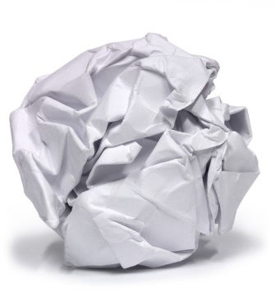
Objective
To practice and revise how to collect data, calculate averages, understand precision, make graphs, interpret results, assess and evaluate the method.

Materials

- two sheets of paper of the same size (from your notebook)
- 50 cm ruler
- Vernier caliper
- millimeter paper

Procedure

Sheet of paper | Length (unit) | Height (unit) | Surface area (unit) | Diameter with ruler (unit) |  |  |  | Diameter with Vernier caliper (unit)
 |  |  |  | Trial 1 | Trial 2 | Trial 3 | Average | Trial 1 | Trial 2 | Trial 3 | Average
1
2
3
- Make table in your lab notebook like the one below: Remember to give it a title and include the units.

- Fold one of the sheets exactly in two and cut it on the line. Repeat this with one of the halves you have.
- Record the the length and width of each piece of paper with a 50 cm ruler in a table. Make sure to include all the significant figures.
- Calculate the surface area and record it in the same table. THINK OF THE UNITS!!!
- Make a ball with each paper and measure its diameter with the ruler 3 times each. (Record all data in your table).
- Calculate the average diameter for each ball.
- Measure now the balls using a Vernier caliper.
- Calculate the average diameter for each ball.

- Plot two graphs of your results (diameter versus the surface area) on millimetre paper. Don’t forget to label the axes (name and unit), to write a title and to include the line of best fit. Make sure the scale of the graph is appropriate.

Graph 1: results obtained with the ruler.
Graph 2: results obtained with Vernier caliper.

Calculations

Questions
- Which of your measurements are based and which are derived quantities?
- Look at your ruler and the Vernier caliper and try to determine the error of both.
- Which instrument is more precise?

Conclusion

- Describe your graph and write a conclusion showing the possible correlation that might exist between surface area of the paper and diameter of the paper ball.
- Are your results precise? Are they reliable? Briefly outline.

Evaluation (Here we want you to think about the procedure or method).
- Go through each step of the procedure in this experiment and consider if there are any possible errors associated with it.
- List a minimum of 2 improvements that could be made in order to obtain better and more reliable data.

Error sources | Improvements

